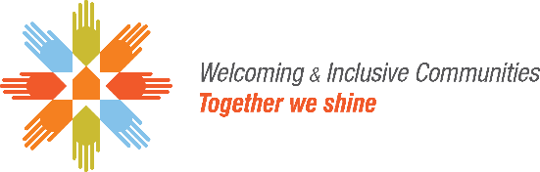
Application Form
Community Readiness for Newcomer Integration
May 2021

AUMA is seeking applications from Alberta municipal governments to participate in AUMA’s Community Readiness for Newcomer Integration project. Successful applicants will be partnered with a consultant to evaluate the readiness of their community or region to support the successful settlement and integration of newcomers and develop an action plan to help overcome barriers and challenges.

- APPLICANT INFORMATION

Municipality: | Click or tap here to enter text. |  | Contact Name: | Click or tap here to enter text.
Email: | Click or tap here to enter text. |  | Contact Title: | Click or tap here to enter text.
Partner municipality (if applicable): |  | Click or tap here to enter text.

- APPLICATION DETAILS

  - How does this project align with your municipality’s long-term goals for the community?
Click or tap here to enter text.
  - What challenges do you expect immigrant newcomers currently experience when settling in the community?
Click or tap here to enter text.
  - What steps has the municipal government historically taken to welcome immigrant newcomers or help newcomers to settle in the community (if no historical action, please state ‘none’)?
Click or tap here to enter text.
  - What types of community organizations are present in the community that are available to support the integration of newcomers?
Click or tap here to enter text.
  - Who will coordinate this project and what is their role?
Click or tap here to enter text.

- CERTIFICATION

--- Please read and check all boxes before submitting your application ---
I hereby acknowledge that:
☐ I have read the Program Guidelines for the Community Readiness Newcomer Integration project and by signing this document, I am agreeing to all the terms and conditions of the Program Guidelines.
☐ The information contained in this application is true, accurate and complete.
☐ I am a representative with designated signing authority for the municipal government.

__________________________________________ __________________________________________
Printed name of authorized representative Title

__________________________________________ __________________________________________
Signature of authorized representative Date

- SUBMISSION

Submit your application via email to AUMA at wic@auma.ca by June 11, 2021 at 4:00 p.m. Mountain Standard Time.

For questions, please contact:
Darren Reedy, Manager of Welcoming and Inclusive Communities
Email: wic@auma.ca
Phone: 780.803.3501

