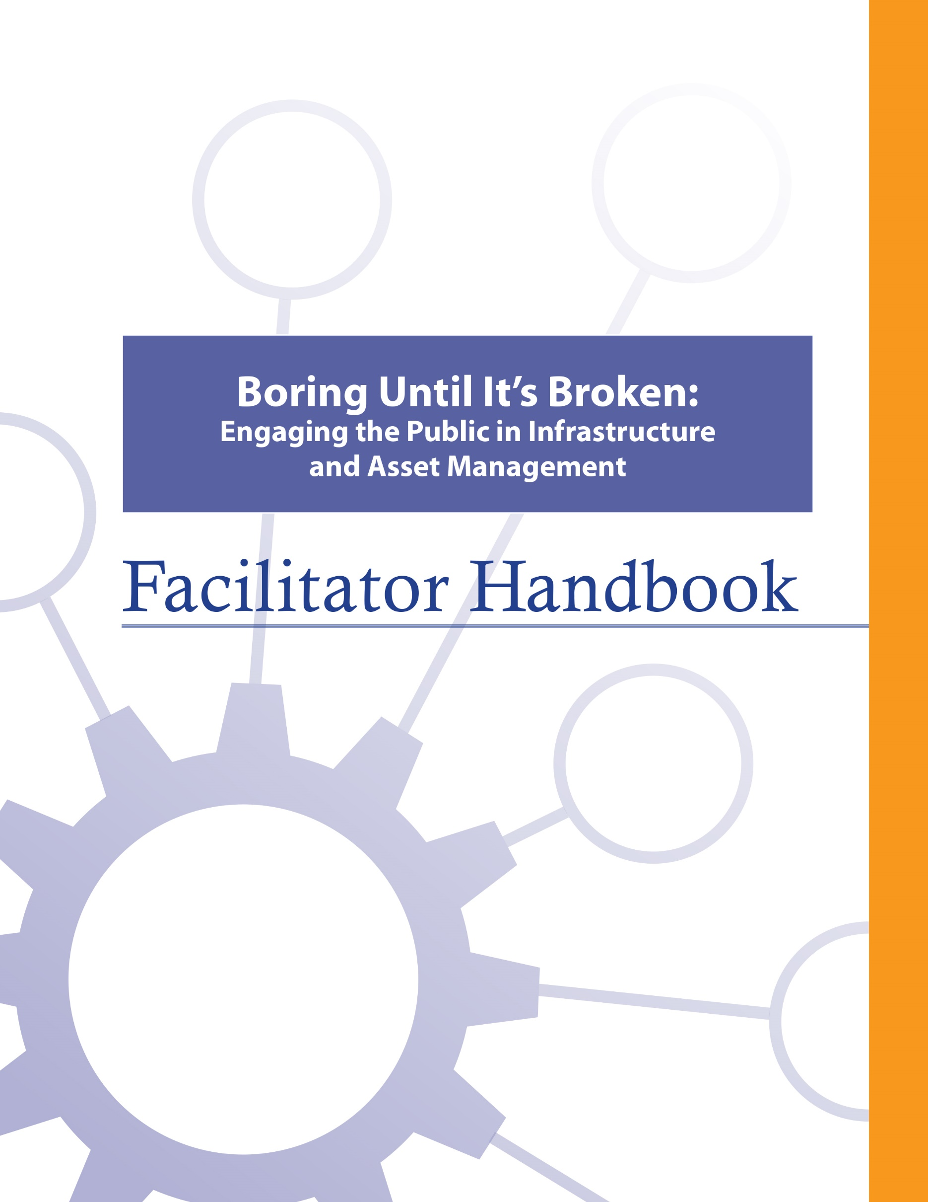
s

About the FCM
The Federation of Canadian Municipalities (FCM) has been the national voice of municipal government in Canada since 1901, advocating for the needs of municipalities and their citizens. FCM’s membership includes large cities, small urban and rural communities, and 20 provincial and territorial municipal organizations.

About RMA
Formerly known as AAMDC, Rural Municipalities of Alberta (RMA) is an independent association representing Alberta’s 69 counties and municipal districts. Since 1909, the RMA has helped rural municipalities achieve strong, effective local government.

About AUMA
Founded in 1905, the AUMA represents 269 urban municipalities including cities, towns, villages, summer villages, and specialized municipalities. AUMA works with federal and provincial governments and business and community stakeholders on a broad range of issues to strengthen the economic, social, cultural, and environmental vitality of its member municipalities.

This initiative is offered through the Municipal Asset Management Program, which is delivered by the Federation of Canadian Municipalities and funded by the Government of Canada.
fcm.ca/assetmanagementprogram

TABLE OF CONTENTS

How to Use this Facilitator Handbook 1
Characteristics of Adult Learners 2
Agenda 6
Introductory Remarks 7
Learning Goal: Asset Management Refresh 10
Module 1—Articulate Why It Is Important to Engage the Public in Asset Management 13
Learning Goal: Articulate Why It Is Important to Engage the Public in Asset Management 13
Learning Goal: Identify Council’s Role in Communication and Engagement 18
Module 2—Identify Who Should Be Engaged and What the Messages Should Be 20
Learning Goal: Identify the Audience and Key Messages and Questions for Engagement 20
Module 3—Identify How to Engage 26
Learning Goal: Identify Good Practices for Engaging with Constituents 26
Learning Goal: Incorporating Community Input 28
Learning Goal: Monitor for Success 31
Learning Goal: Concluding Remarks 33

How to Use this Facilitator Handbook
This Facilitator Handbook was created to be a resource for the professionals who will be instructing the course on behalf of the AAMDC and AUMA. The Facilitator Handbook is intended to help instructors to provide consistency, and to facilitate the course effectively, within the instructional time available.

How to read the guide:
- The facilitator script and instructions are provided in the right column.
- Thumbnails of the slides corresponding to the script are in the left column.
- The facilitator’s script appears in normal type.
- Additional notes to facilitators appear in bold print.
- Sample responses, discussion points and answers for participant activities appear in italics.

Characteristics of Adult Learners
While we may act like it sometimes, adults are not just big kids. And, we don’t want to be taught like children. As adults, we learn in a very different way than our shorter, younger (maybe even thinner) selves. When we think about a typical learning environment, many of us recall past school days. During those times, our very identity revolved around being a student.
For most of us, the model we have for instructing comes from the teachers who taught us back in the day. However, the teaching techniques that worked for our grade eight English teacher may not be as appropriate for those of us now instructing adults – adults who are also our colleagues and peers. It is important for facilitators of adult education to understand how adults learn and to incorporate teaching principles and strategies that will meet the unique needs of adults and foster the most positive, engaging and productive learning environment possible for them.
What is so different about adults and how can we, as training professionals, incorporate instructional techniques that respect those differences? Below are some generally accepted insights that you may find helpful.

Adults want to have control over their learning
We adults tend to be self-directed. We have work, family and community responsibilities that require us to exercise some level of competence and control. In fact, we can get downright resentful when others take away our right to make choices around our own affairs. This is true when it comes to our learning experiences -- we typically need to exercise some control here, too. In fact, take away our sense of control over how and when we engage in formal learning and you will likely meet some resistance.

What’s a facilitator to do?
- Include adult learners in the planning of their learning (engage them in needs assessments and encourage their input on course objectives & content wherever possible).
- Encourage self-assessment and self-evaluation (rather than instructor-based evaluation).
- Establish a peer relationship with learners rather than the traditional hierarchical one.
- Make yourself available to adult learners outside of the formal learning environment if possible.

Adults, more so than youth, draw upon their experiences as a resource in learning
Been there, done that. Adults have a wealth of past experiences simply because we’ve lived longer than youth. As learners, our past experiences are important resources that we draw on. Adults tend to link new learning to prior learning (much of which is rooted in life experience). Learning is all about accepting and applying new ideas and concepts. For adults, that process often happens within the context of how the idea or concept “fits” with what we’ve already experienced.

What’s a facilitator to do?
- Take time to get to know the experiences of your adult learners and be intentional about helping them link new concepts and ideas with prior learning or experiences.
- Encourage open discussion on how new concepts and ideas being presented fit with the experience of learners.
- Encourage learners to share their experience for the purpose of teaching others. Ask versus tell. Using questions can draw out the information you want to focus on and is an effective way to encourage adult learners to apply their own skills and experience to facilitate their learning.

Adults tend to be more motivated in learning situations than youth
When adults find themselves in a formal learning environment, most times it’s because they want to be there. Adults are not typically motivated by gold stars or good report cards. Instead, they want a learning outcome that can be put to use immediately in concrete, practical and self-benefiting ways.

What’s a facilitator to do?
- Don’t spend a great deal of effort trying to motivate adult learners. Rather, see your role as facilitating the learning they are ready to experience.
- Ensure teaching is relevant to what learners want to learn and what they will be able to use back on the job.
- Accept that people will learn at different rates and in different ways. Some will learn by being told, others will learn by doing. Still others will need to be shown. Use a diversity of teaching methods to ensure your learners stay motivated to learn.

We’re generally more pragmatic in learning than youth
Adults are typically more interested in problem solving than information gathering. Learning “theory,” which must be stored away for future use, can be frustrating and seem irrelevant for many adult learners. Especially for adults, learning becomes complete when we put into practice what we are attempting to learn.

What’s a facilitator to do?
- Using job-related case studies and hands-on exercises and activities will help learners to immediately use what they’re learning in a problem-solving situation. The more often we use what we have learned, the better we can perform or understand it.

Some adults lack confidence in their learning
Some adults who have been away from a formal learning environment for some time may consider the learning “glory days” over. These perceptions can influence how confident they feel during learning situations. Interestingly, research shows that the attention span of the average adult is between 8 and 20 minutes.

What’s a facilitator to do?
- Provide opportunities for learners to receive constructive feedback on how they’re doing (either through guided self-evaluation, constructive input from other participants, or the facilitator’s own observations).
- Present information in a manner that permits mastery in “bite size chunks” with opportunity for hands-on application.

Many adults are more resistant to change than youth
Learning often involves change of some kind. Youth tend to be more idealistic and are often open to change just for the sake of change. However, over the course of being an adult, our experiences around change have not always been good and can lead us to be somewhat resistant to it.

What’s a facilitator to do?
- Encourage learners to explore the “why” of change, not just the “how.”
- Link new concepts to older, understood and accepted concepts.

A group of adult learners will typically be more diverse than a group of youths
A group of adults, more so than a group of youths, will vary a great deal in terms of age, experiences, and backgrounds. Differences can be a powerful resource for learning as adults collaborate together on tasks.

What’s a facilitator to do?
- Allow time for interaction between learners and create opportunities for them to work together in groups to collaborate and share perspectives and experiences.
- Present material in a variety of ways to accommodate a diversity of learning styles.

Agenda
Time | Topic | Facilitator’s Name
10 minutes | Introductory Remarks
20 minutes | - Asset Management Refresh
40 minutes | - Articulate Why It Is Important to Engage the Public in Asset Management
30 minutes | - Identify Council’s Role in Communication and Engagement
15 minutes | Refreshment Break
45 minutes | - Identify the Audience and Key Messages and Questions for Engagement
30 minutes | - Identify Good Practices for Engaging with Constituents
20 minutes | - Incorporating Community Input
20 minutes | - Monitor for Success
10 minutes | Concluding Remarks

Facilitator Preparation
- Print examples of communications and engagement approaches – enough for each table.

Introductory Remarks

10 minutes |
Slides | Script
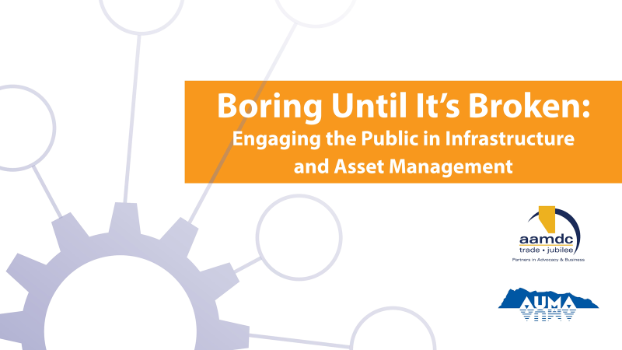
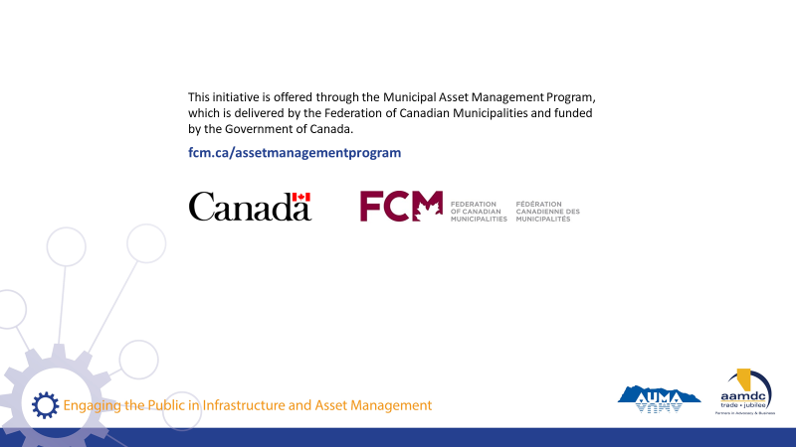
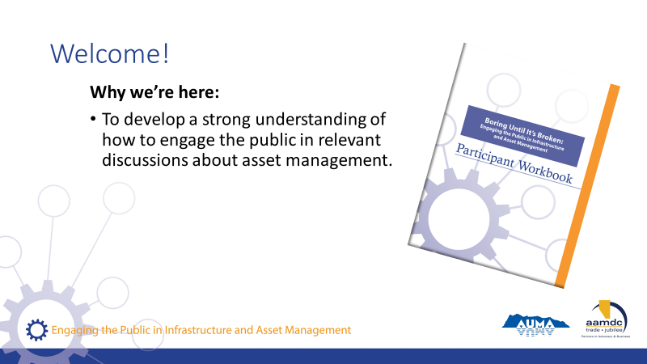 | State:  - Welcome to our course on communications and engagement in asset management.  - We’re here to develop a strong understanding on how to engage the public in relevant discussions about asset management.
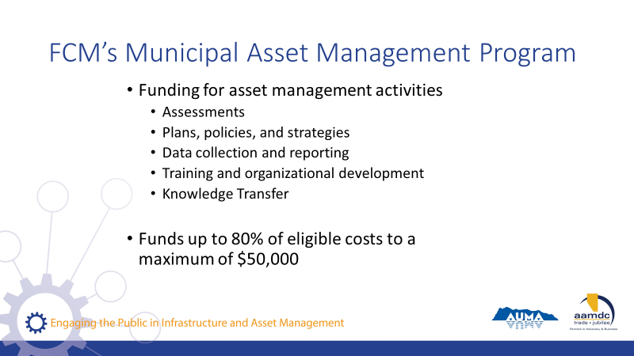 | State:  - Before we get started, we also want to mention that there is funding out there to do asset management.  - So, as you’re learning today, if you’re identifying things you’d like to bring back to your community, know that this grant program is available.  Read slide.
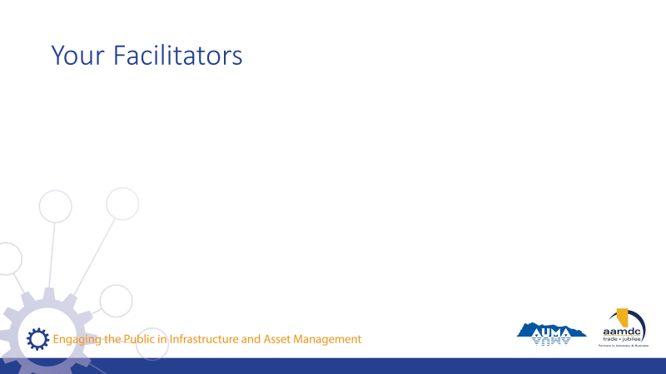 | Facilitator(s) introduce themselves.  Have participants introduce themselves.  Consider the use of icebreaker questions about why participants want to learn more about communications and engagement related to asset management.
Review how to use the learner workbook.

Key messages:
- Everything covered today is in your workbook.
- Encourage you to read the workbook from start to finish.
- Recurring icons are used to help you find relevant information easily,

As icons appear (with click) on slide, review what each means and how to use it.
State:

The course is based on achieving specific learning goals. This icon identifies the learning goals, so you can be thinking about whether you are achieving them.

This icon lets you know we’ve added an interesting fact or additional information related to the course material that we may not specifically cover in our discussion.
When you see this icon, it means we have included a reference to additional information on the topic that you can review later.
Throughout the course, we will provide opportunities for you to apply your knowledge and share your expertise in groups through various activities related to what you are learning.

In discussing municipal governance, there are a number of terms that may not be familiar to everyone. We’ve highlighted a few in these Glossary boxes and provided definitions. If you spot a term you aren’t familiar with and we haven’t provided a definition, please let us know by filling out the evaluation form and we will not only address it in this course but will add it to future participant workbooks.

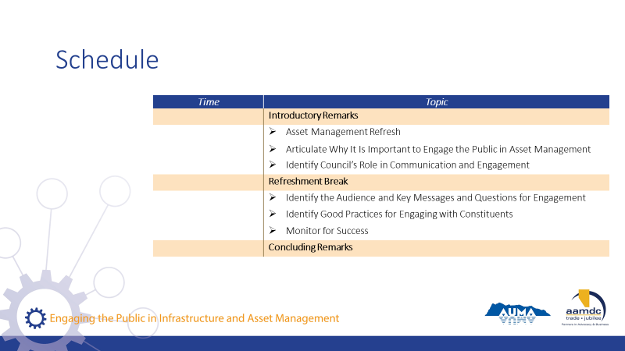 | Review course outline schedule.  State:  As you can see, we will be covering a lot of content today.

Learning Goal: Asset Management Refresh

20 minutes |
Slides | Script
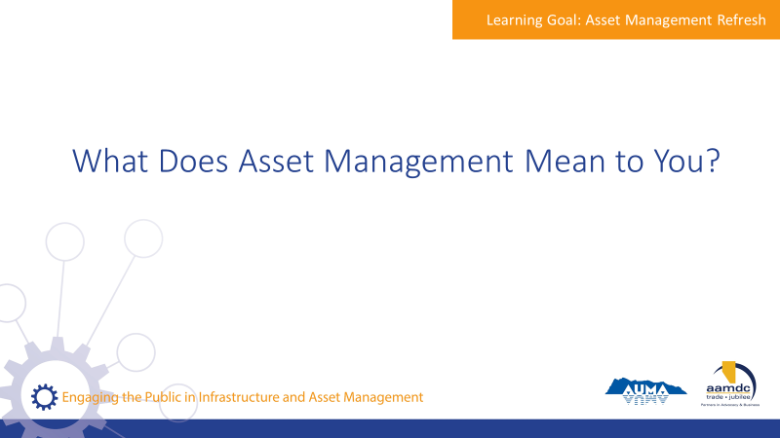 | State:  Let me ask you, when you hear the term asset management, what comes to mind?  Encourage participants to share their thoughts with the large group.
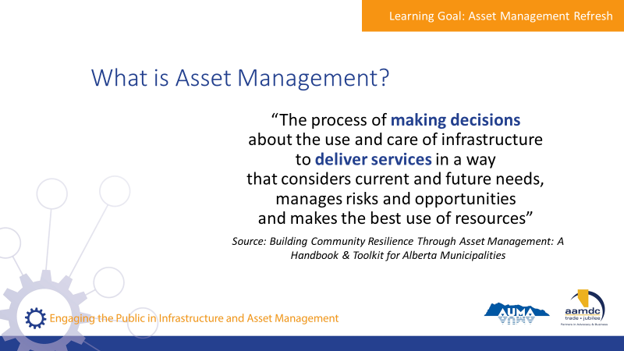 | State:  - Municipalities in Alberta are empowered to provide a range of services to their communities through provincial legislation, specifically the Municipal Government Act (MGA).  - A major component of service provision is taking care of the assets that make those services possible.  - An asset, also known as a tangible capital asset (TCA), is a physical component of a system that enables a service, or services, to be provided.  For example, pipes are the assets that deliver water service to homes, roads and traffic lights are the assets that make transportation possible, and recreation centres are assets that allow recreation services to be provided to the community.  - Municipalities have been managing assets for a long time. However, asset management is more than just managing assets or developing inventories of the assets a municipality owns.  - Here’s one definition of asset management that we think captures the essence of what it really is. We took this from the Alberta Handbook and Toolkit.  Review definition from slide.  State:  - They key terms here are “making decisions” and “deliver services”.  - Asset management is about using systems and processes to balance cost, risk, and LOS to make informed decisions that make sense for your community in the long run.  Assets don’t exist for the sake of having assets, they exist to deliver services. Service delivery is the starting point for all asset management.  Question for participants:  - What is the role of elected officials in asset management?  - What is the role of the CAO and administration?
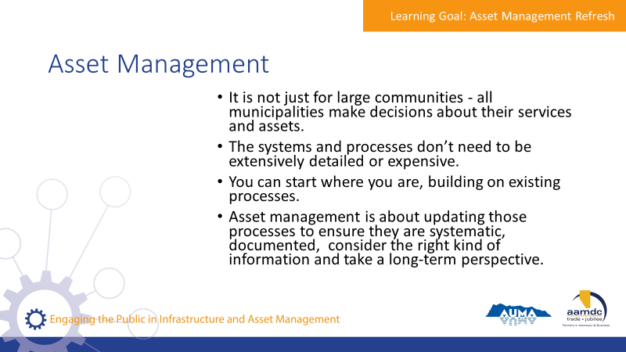 | State:  - It is not just for large communities. All municipalities make decisions about their services and assets.  - The systems and processes don’t need to be extensively detailed or expensive.  - You can start where you are. Your municipality probably already uses processes for things like planning and budgeting.  - Asset management is about updating those processes to ensure they are systematic, documented, consider the right kind of information and take a long-term perspective.
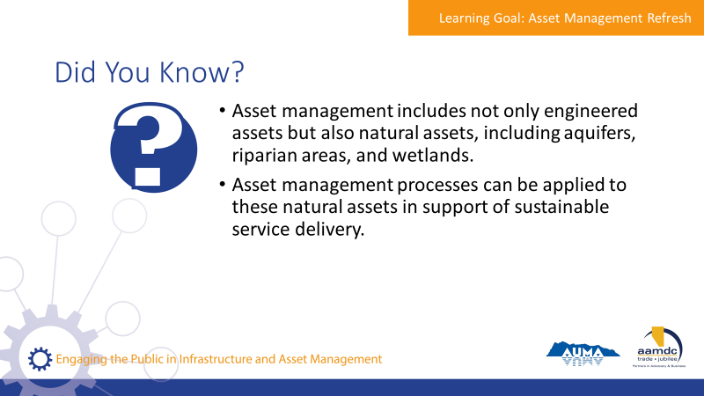 | State:  - Here are a few facts we thought you would find interesting. [Read facts on slide].  - Natural assets are critical to service delivery, and it’s useful to think through how these assets are cared for and invested in, in the same way that infrastructure assets are.  - Does anyone know if their AM programs include consideration of natural assets?
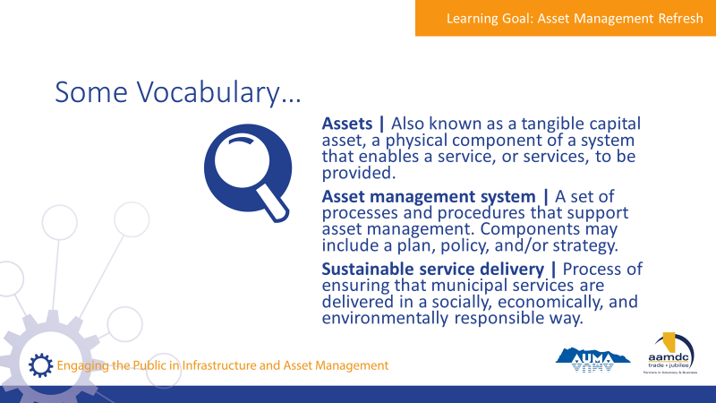 | State:  - There are a couple of terms we will be using as we discuss asset management, so we want to make sure we have a common understanding of them before we get into our discussion of asset management.  Review terms on slide.
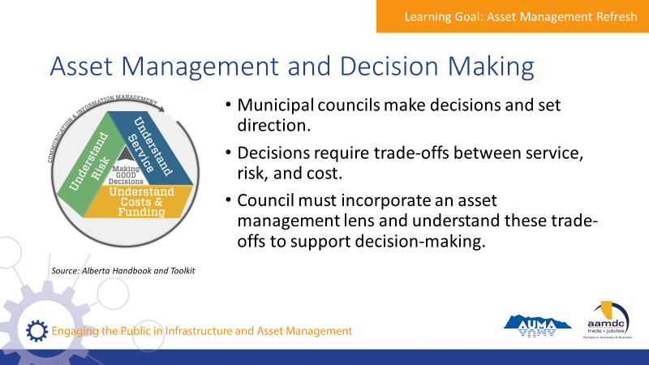 | State:  - Council’s role is to make decisions and set directions.  - Decisions require thinking about trade-offs between service, risk, and cost.  - Council should incorporate an asset management lens on decision making processes and request information from staff to understand these trade offs.
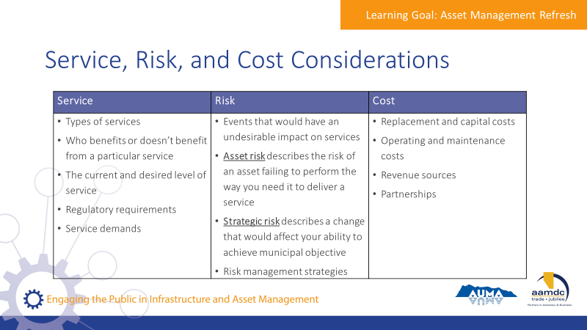 | State:  - This chart shows a summary of what should be considered for service, risk, and cost when evaluating trade-offs  - Many public engagement considerations are about communicating these trade-offs and understanding from the public what their priorities are.  Review considerations on slide.

Module 1—Articulate Why It Is Important to Engage the Public in Asset Management

Learning Goal: Articulate Why It Is Important to Engage the Public in Asset Management

40 minutes |
Slides | Script
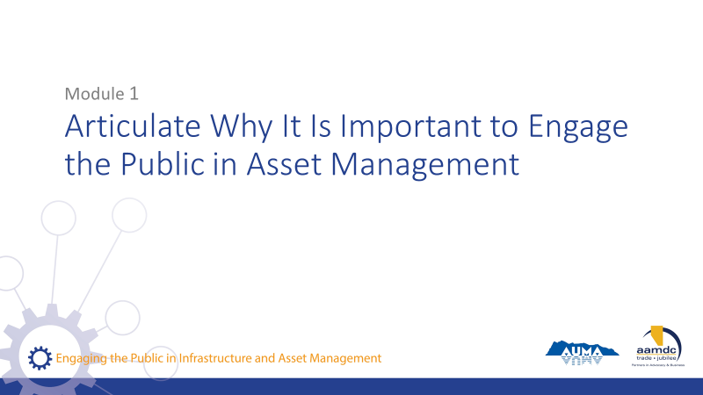 | State:  - This course has been designed with specific learning objectives for each module to state what learners should be able to do after completing a module.  - After Module 1, you should be able to:  - Articulate why it is important to engage the public in asset management  - Identify council’s role in communications and engagement  - If you don’t feel like you are mastering these learning objectives, or if you have questions about any of the content, we want to encourage you to let us know. Ask questions during the course at any time or see us during the break.  - Also, you will get out of the course what you put into it. So please participate fully and if there is anything that may get in the way of your full participation, we want to know that as well.
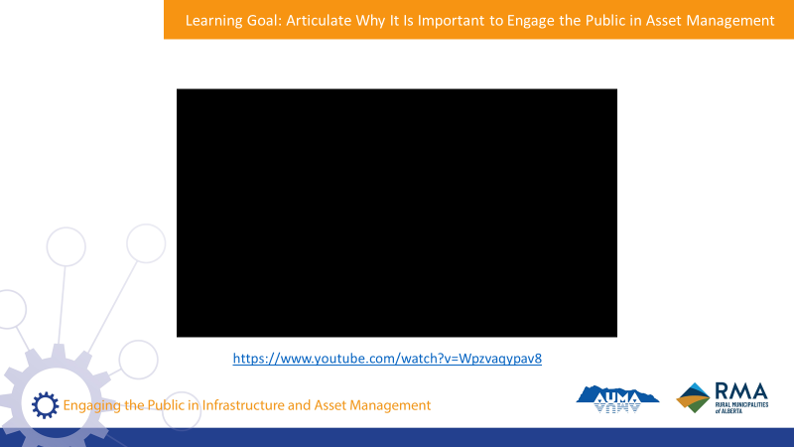 | State:  - Most often, infrastructure assets are invisible to the public until something goes wrong.  - You don’t notice the quality or condition of your roads until there is a pothole, or how much water you use until there are water restrictions in place.  - Let’s watch a short video on infrastructure as the general public often hears about it.  Play first 8 minutes of video.
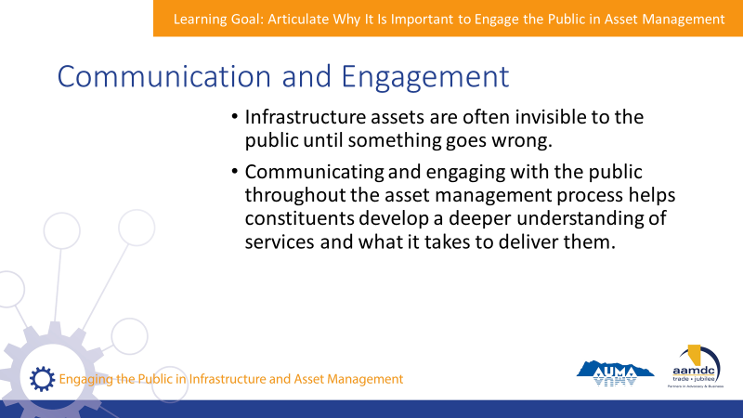 | State:  - The public usually doesn’t hear much about infrastructure until there’s a problem with it.  - Through communicating and engaging with the public throughout the asset management process, there’s an opportunity to help constituents develop a deeper understanding of the services they receive and what it takes to deliver them.
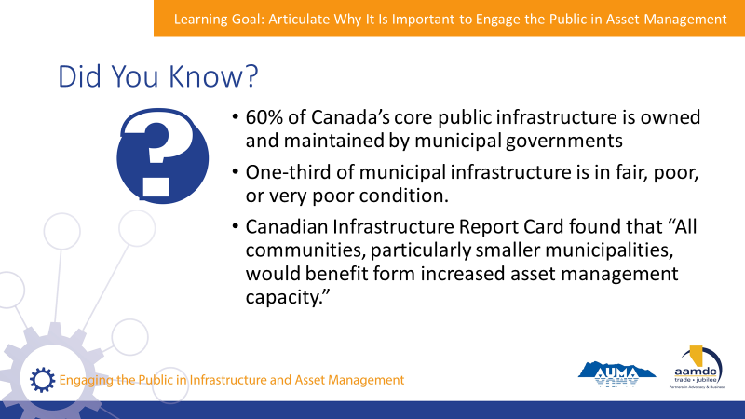 | State:  - Here are a few statistics we thought you would find interesting. Do any of these surprise you?  - They serve to set the context for why asset management has become increasingly important in Canada.  - Members of the public may have also heard about these issues through the media, and may want to know what their municipality is doing about it.
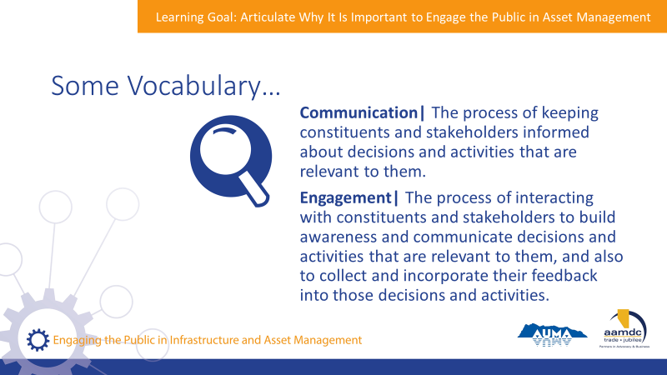 | State:  - To make sure we’re all on the same page when we talk about communications and engagement, let’s review a few definitions.  Read definitions on slide.
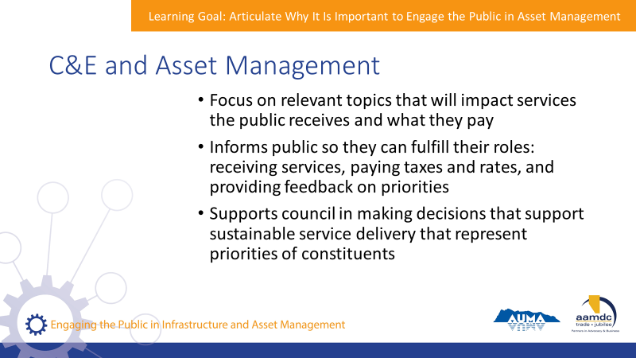 | State:  - To be clear, this is not about trying to engage the public in conversations about the full process of asset management. People may not be that interested in the details of what the municipality is doing to manage assets, but they do want to know they can trust the municipality to make good decisions, to steward the sustainability of services they rely on, and to be engaged in conversations about things that will impact them.  - It is about engaging and communicating about relevant topics that will impact the services the public receives and what they pay to receive these services.  - Just like council and staff have a role to play, constituents also have a role to play in services.  - They receive services, pay taxes and user fees, and provide feedback to the municipality about their priority.  - Engaging the public also helps council fulfill their role in asset management, which requires making decisions to steward sustainable service delivery and represent the priorities of the community.
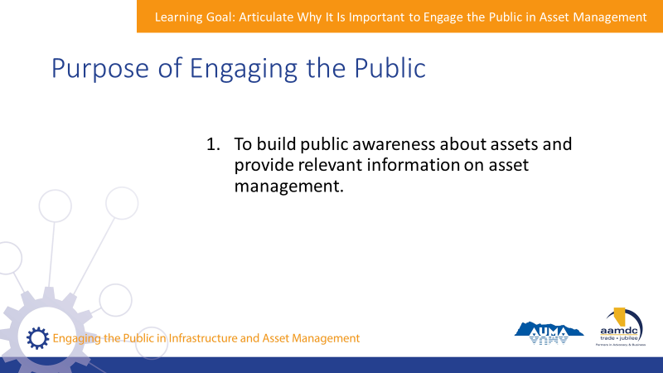 | State:  - Let’s get in to the purpose of engagement the public.  - First, it’s to build public awareness about assets and provide relevant information on asset management.  - Your constituents don’t need to know the ins and outs of asset management, but it’s important they understand the need for the municipality to responsibility prepare for the future.  - For example, after a municipality builds a new recreation facility, they may begin allocating a little bit of funding each year to a capital reserve that can be used to renovate the facility when required.  - The public needs to understand that building a new facility is not the end of capital expenditures on that facility; it’s really only the beginning.
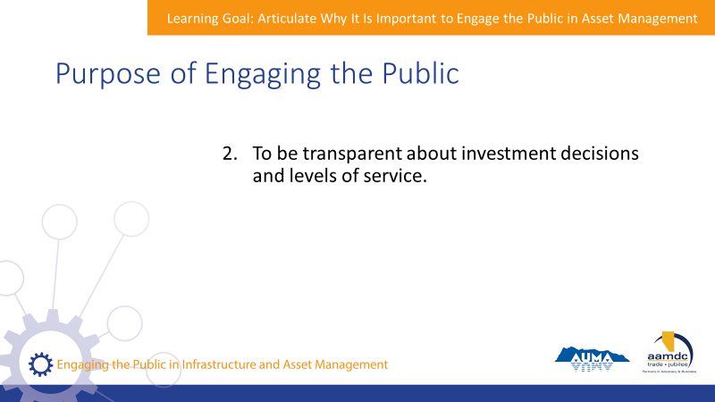 | State:  - Second, public engagement helps support transparency about investment decisions and levels of service.  - This is important to enable the municipality to build trust.  - Municipalities are often faced with decisions that are financially significant and will impact levels of service.  - For example, when upgrading a wastewater treatment plant to meet changing regulations, a municipality may make the decision to upgrade plant capacity at the same time as treatment technology.  - Or when resurfacing roads, a municipality may need to prioritize roads according to risk and available funds.  - Since different people will benefit sooner than others, it’s important that the municipality can communicate why decisions were made and how they will impact service levels, today and into the future.
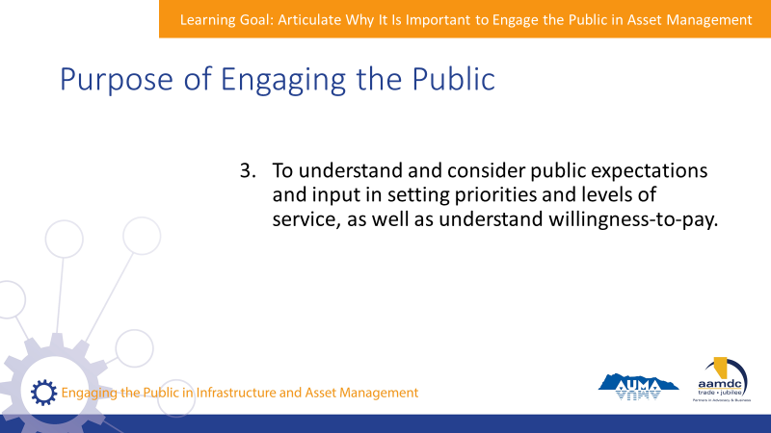 | State:  - Third, engaging the public helps staff and council understand and consider public expectations and input in setting priorities and levels of service, as well as understand willingness-to-pay.  - People will always have opinions and expectations about the level of service they receive.  - These people are ultimately the recipients of the service – and service delivery is the core purpose of assets - so it is important that their input is considered.  - However, it isn’t helpful to just know what someone wants – it’s important to also know what they’re willing to pay for it.
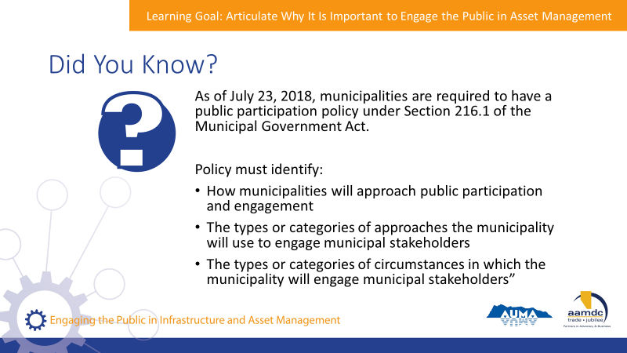 | State:  - As of July of this year, municipalities are required to have public participation policies under Section 215.1 of the Municipal Government Act.  - These requirements came into effect in October 2017 and municipalities have 270 days to comply by passing their policy.  - The policy must identify:  Read slide.  - More information an be found in the Public Participation Policies and Public Notification: A Guide for Municipalities, which was developed by the Alberta Government, AUMA, and RMA.
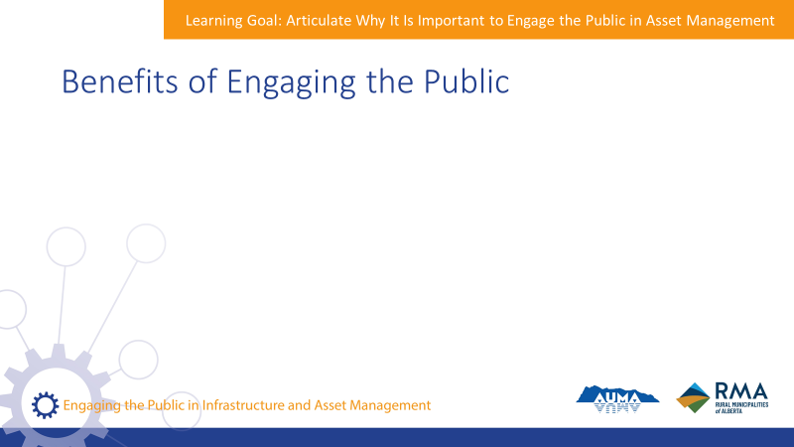 | State:  - Though it can be challenging at times, there are many benefits to engagement the public.  Ask the group:  - What are some of the benefits?
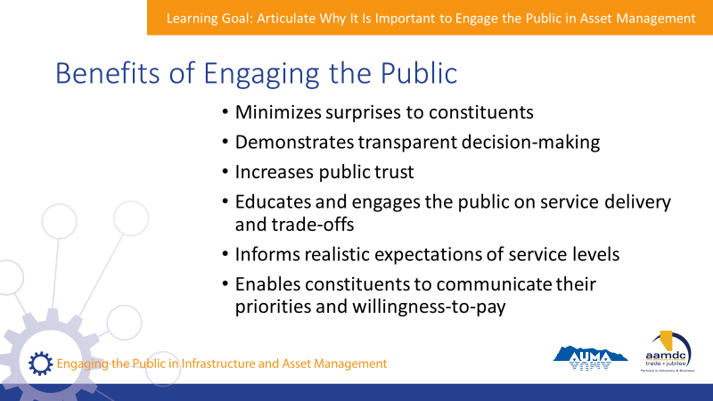 | State:  - Great answers!  Read slide to review anything that might have been missed.
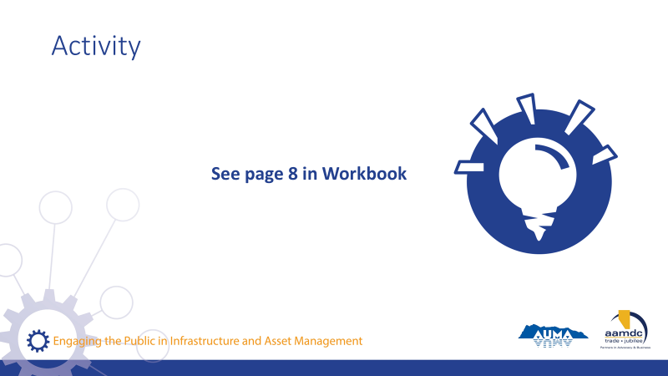 | Activity – page 8 (15 minutes)  State:  - Let’s all turn to page 8 in the workbook.  - Working with your table groups, read the questions on page 8 and at the top of page 9.  - Write down your answers on sticky notes.  - Write down one thought per sticky.  Ask the group:  - What answers did you come up with?  Collect stickies and organize together.  Ask the group:  - What do you think the public is missing?
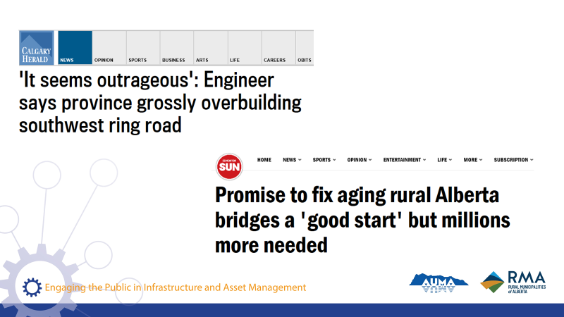 | - Your constituents hear about infrastructure and infrastructure issues in the news a lot. Usually the news is negative.  - Think about some recent stories you may be heard about in the news.  - In Calgary, the southwest ring road has been criticized for being too big and too expensive – beyond the projected needs of the city.  - In rural communities, the provincial governments promise of funding for fixing local bridges, resource roads, and small airports was hailed as a good start, but not enough to solve all the challenges facing rural communities related to aging infrastructure.
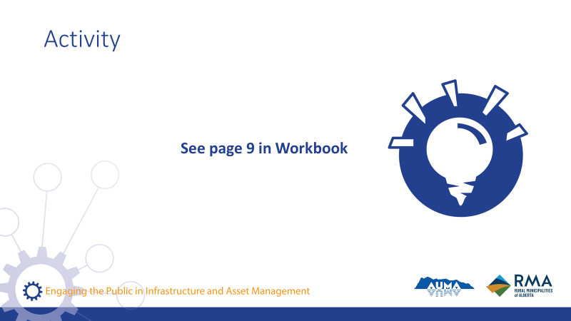 | State:  - Turning back to your table groups, read through the thought experiment on page 9.  - Put yourselves in the shoes of a few “typical” constituents in your community.  - Think about what they might know about infrastructure and service delivery and discuss common perspectives of infrastructure and service delivery.  - What are people thinking about?  - What is the public’s role in asset management and sustainable service delivery?  - Discuss in your groups and record your answers.  Debrief as a larger group. Ask each table to briefly share their discussion.

Learning Goal: Identify Council’s Role in Communication and Engagement

30 minutes |
Slides | Script
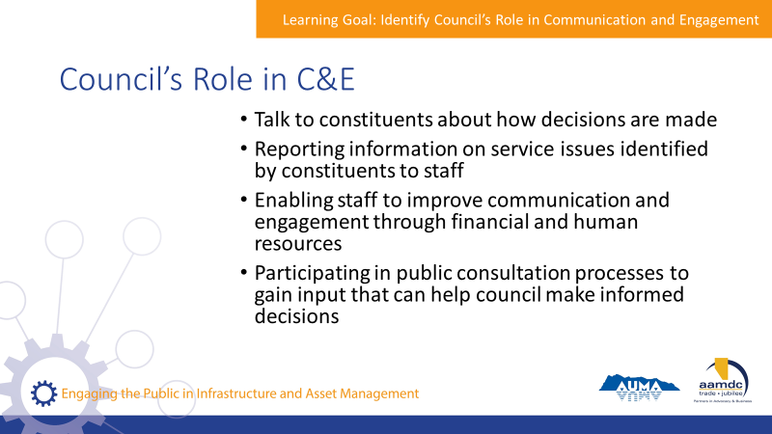 | State:  - The public may not notice infrastructure until something goes wrong.  - However, when they do notice, council members are often the first to hear their complaints.  - Because of this, it’s important that councillors are able to communicate effectively about how decisions are made and how the municipality responds to complaints.  - Council’s role in communications and engagement includes:  Read slide.
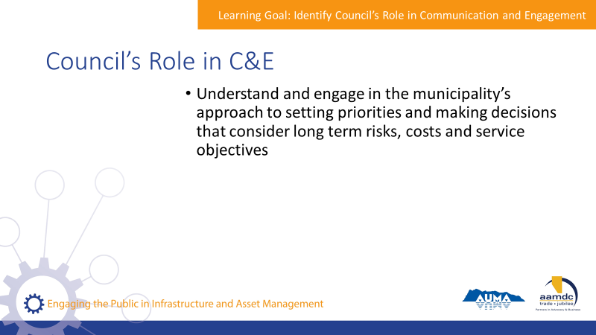 | State:  - To be able to effectively fulfill their role in communicating with the public, council members should understand and engage in the municipalities approach to setting priorities and making decisions in a way that considers long-term risks, costs, and service objectives.
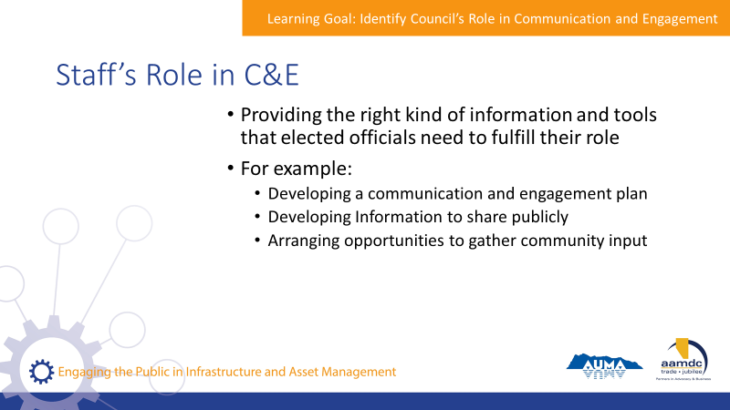 | State:  - Staff play an important role in helping council fulfill the roles just discussed.  - They do this by providing the right kind of information and tools to elected officials to help them fulfill their role and communicate effectively with the public.  - They may do this by:  Read examples on slide.
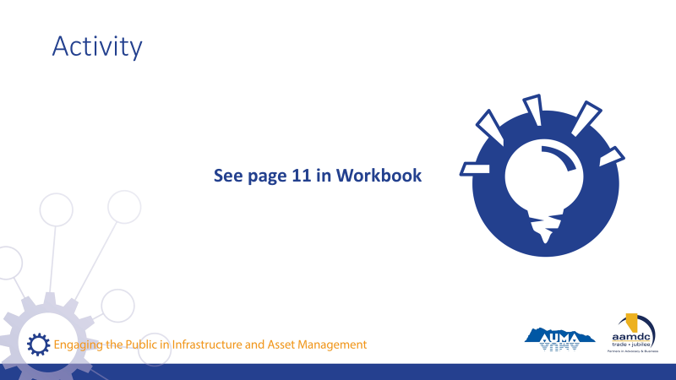 | Activity – page 11 (15 – 20 minutes)  State:  - Let’s turn to page 11 in your workbooks.  - Working with your table groups or pairs (depending on size of group), answer the questions on page 11 and 12.  Debrief as a group. Going through each question, ask a few tables or pairs to share their answers.

Break
15 minutes |

Module 2—Identify Who Should Be Engaged and What the Messages Should Be

Learning Goal: Identify the Audience, Key Messages and Questions for Engagement

45 minutes |
Slides | Script
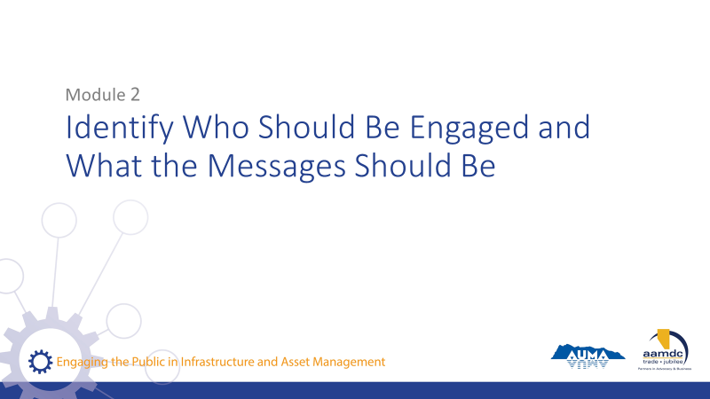 | State:  - In the next module, you will be learning:  - To identify the audience and key messages and questions for engagement  - As an elected official, you’ve already had a lot of practice communicating with, and engaging, the public.  - It’s a critical part of what you do.  - In this part, we’ll talk about some general best practices for communication and engagement, as well as some specific considerations for asset management and service delivery.  - In addition to the ongoing conversations you have with your constituents, there are several instances where your municipality may have specific objectives for communicating with and engaging the public.  - Staff are responsible for preparing for and conducting public engagement.  - Council has an important role in advising the direction of the engagement.  - As decision-makers, council also supports by confirming the role of stakeholders and stakeholder input in the decision-making process.  - It is important that the role of stakeholder input is understood before engagement is completed, in order to manage expectations with stakeholders.  - Elected officials in some communities may even participate in communication and engagement initiatives.
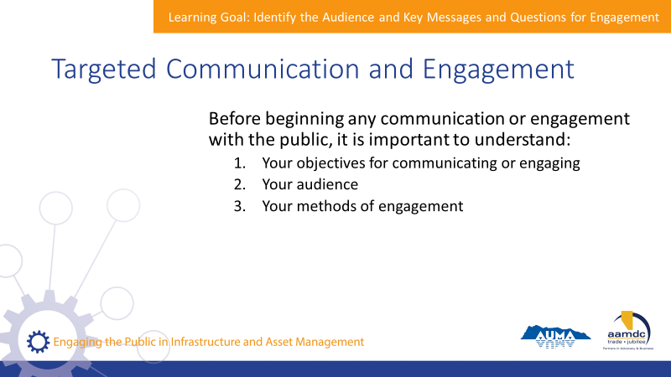 | State:  - Before you begin any communications or engagement with the public, it’s important to understand a few things:  Read points on slide.  - Let’s go into these in more detail.
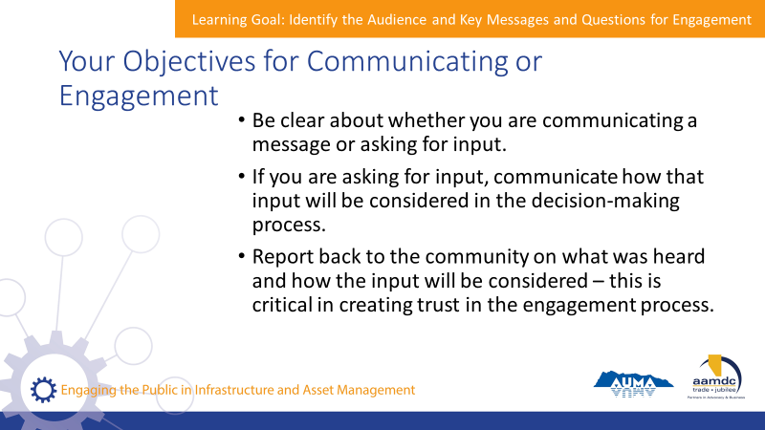 | State:  - When going to the public, it’s important to have clear objectives, otherwise constituents may be confused about what you are asking of them, and they may get frustrated if it is not clear how their input will be used.  - Some key considerations for understanding your objectives:  - Be clear if you are simply communicating a message, or if you are asking for input.  - If you are asking for input, know how it will be used in the decision-making process.  - Do not ask for input if your municipality is not able to use or respond to that input.  - This doesn’t mean that you can do everything that constituents ask for, but expectations can be managed if you can communicate how input will be considered.  - It also lets you communicate to the public that their input will be considered along with input form other stakeholders, financial considerations, staff capacity to implement, and the need to manage different risks.  - If your intentions in asking for input are clear, people can be generally satisfied with a process, even if the decision is different than they originally wanted.  - Of course, you can’t make everyone happy.  - But being transparent in your engagement process can at least help constituents better understand the process and other things that are being considered.  - An important part of asking for input is reporting back to the community on what was heard and how their input was considered.  - This is a way to build trust for the engagement process and encourage constituents to engage the next time.
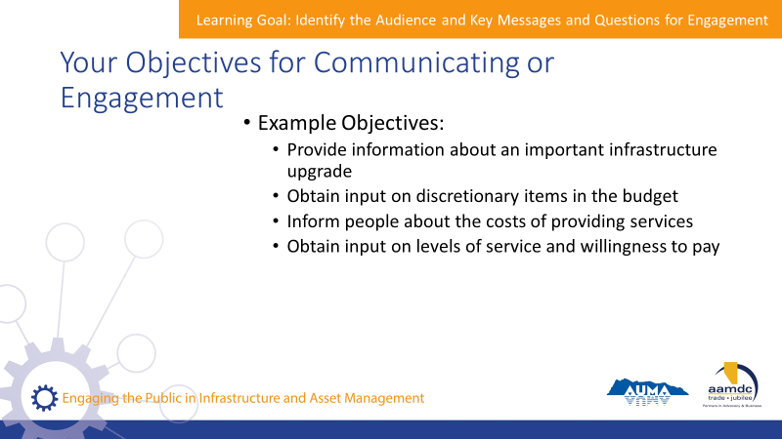 | State:  - It’s helpful to articulate what your objectives are when engaging the community.  - For example, consider those on the slide:  Read slide.
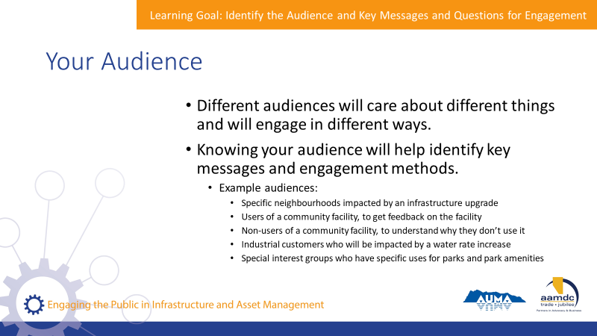 | State:  - It’s also important to consider your audience. Different audiences – by which we mean, constituents from different neighbourhoods, demographic groups, or with special interests – are going to care about different things and engage in different ways.  - By knowing who your audience is, you can help identify your key messages and figure out what the best way is to engage your audience in order to achieve your objectives.
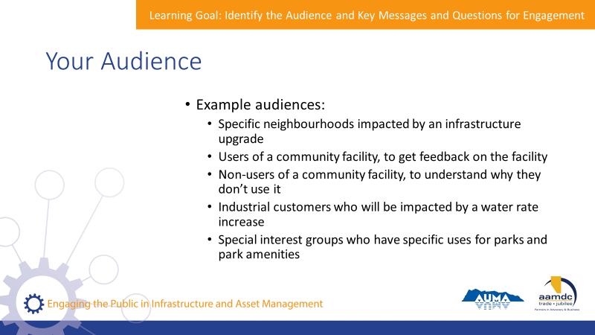 | State:  - The slide shows some examples of audiences that may be important in the context of asset management and service delivery.  Read slide.  What are some examples of audiences in your communities?
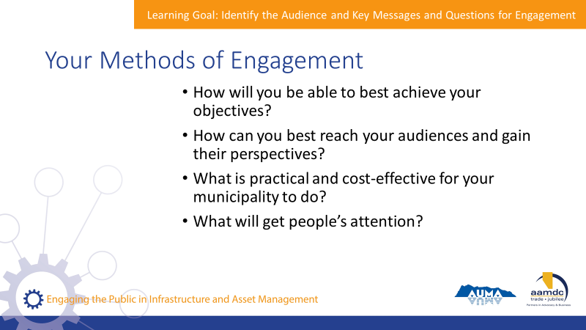 | State:  - The third consideration is your methods of engagement.  - How will you best be able to achieve your objective and reach the audience you want?  - Also, what is practical and cost-effective for your municipality?  - What will get people’s attention?
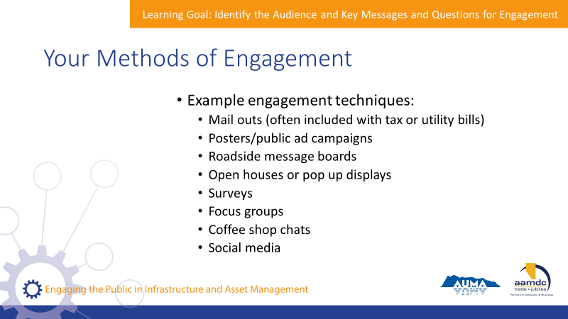 | State:  - There are numerous methods of engagement.  - The slide shows a number of common methods used in engagement on infrastructure and service delivery.  Read slide.  - Generally, it’s staff who lead the engagement process, who collect feedback, and integrated it into the planning process in a meaningful way.  - Sometimes consultants are hired to help with this process.
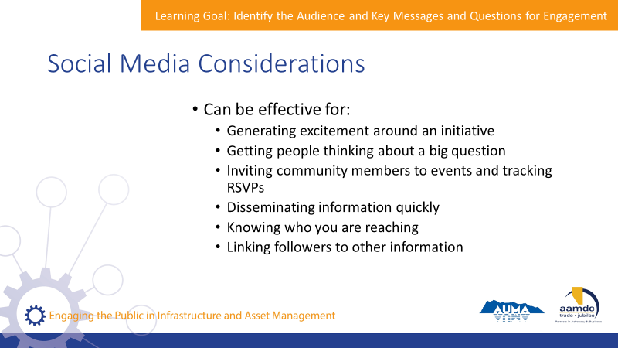 | State:  - Ask: Who actively uses social media to engage the public? How do you use it?  - We all know how important social media tools, such as Facebook or Twitter, among others, have become in engaging with the public.  - In many communities, members of the public expect to be able to voice their feedback or ask questions through these easy to use platforms.  - Social media can be effective at accomplishing a number of goals.
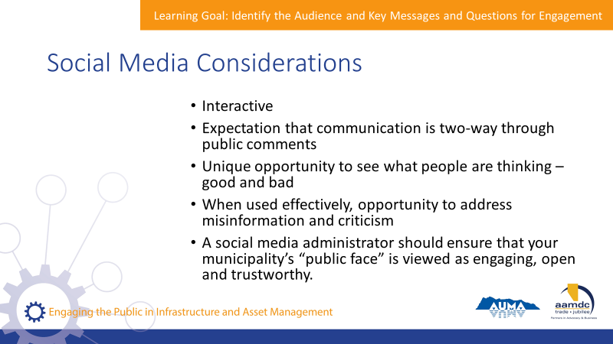 | State:  - When thinking through your social media presence, or how it can be used to engage your community, remember that’ it’s interactive.  - Users expect two-way communication and often disengage if comments are closed or there is no mechanism for them to receive responses.  - When public dialogue is encouraged, there is an opportunity to hear both positive and negative feedback and gain a better understanding of how community members think and feel about what the municipality is doing.  - There is also an opportunity to identify and address misinformation or criticism in a way that builds trust.  - But it is not as straightforward as creating an account and forgetting about it.  - A competent social media administrator will ensure inappropriate comments don’t get airtime on your accounts.  - And that your municipalities “public face” is engaging, open, and trustworthy.
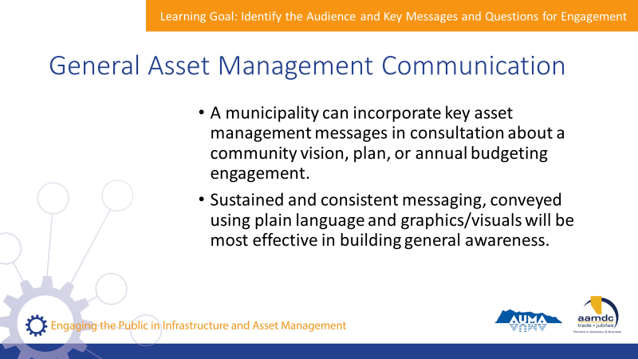 | State:  - Engaging with the public about asset management and service delivery doesn’t have to happen as a standalone process.  - In fact, asset management won’t mean much to your constituents on its own.  - What does matter is the role of asset management in providing services, supporting good governance and decision-making, and keeping costs manageable.  - Communications offers an opportunity to show your constituents how your municipality is responsibility delivering services and managing infrastructure, and build trust with constituents.  - And engagement is an opportunity to collect feedback on services that can be used to improve the work you are already doing.
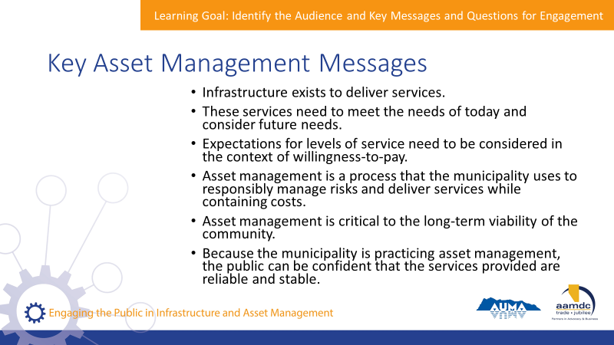 | State:  - Key messages about asset management can be incorporated into a variety of engagement process.  - For example, when the municipality is developing a community vision or plan or doing annual budgeting.  - The slide shows some key messages that can be incorporated into different engagement processes.  Read slide.
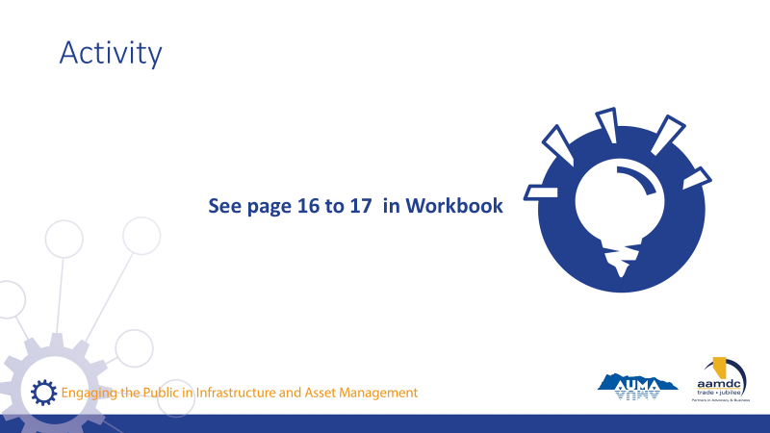 | Activity – page 16 (20 minutes)  State:  - Let’s turn to page 16 in your workbook.  - In small groups, share an example of communication and engagement in your community that is related to infrastructure or service delivery.  - Through discussion, answer the questions on page 16.  Debrief as a group.  Ask:  - Let’s go around to each table.  - Please share one story of communications and engagement in your community and some of your answers to the question in your workbook.  State:  - Turn back to your table groups.  - Brainstorm some ways you could incorporate general messaging about asset management and service delivery into your communications.  - Once you have brainstormed some ideas, brainstorm what benefits you might see in your community from this kind of communication and engagement.  - You can write your answers on page 17.  - We’ll regroup and discuss altogether.  Debrief as a group.  Ask:  - What ideas did you come up with for incorporating messages on asset management and service delivery, and what benefits might you see from doing this?  - Please share an example from each of your tables.

Module 3—Identify How to Engage

Learning Goal: Identify Good Practices for Engaging with Constituents

30 minutes | 11:00 a.m. to 11:30 p.m.
Slides | Script
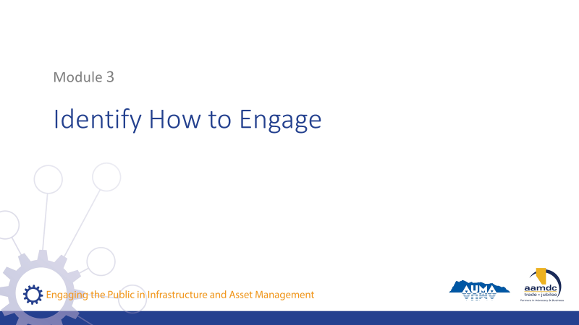 | State:  - In the next module, you will be learning:  - To identify good practices for engaging with constituents  - To monitor for success
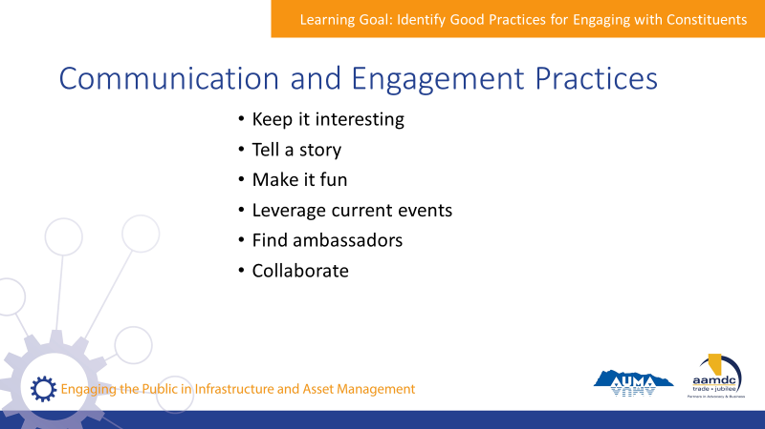 | State:  - When you’re communicating with the public, there are some good practices to keep in mind to help you be more effective and achieve your objectives.  - While it is the responsibility of staff to develop and implement methods for public engagement, council provides direction on communications and engagement.  - Council should also know the results of any engagement efforts because these may be considered in decision-making.  - Your workbook outlines a number of good practices for communications and engagement on asset management:  - Keep it interesting – relate asset management to the things people care about – the services they receive, having their voices heard, and minimizing taxes and fees.  - Tell a story – connect asset management and service delivery to broader community goals.  - Brand it – Branding helps make the message identifiable.  - Make it fun – There are many tools and strategies out there to help you collect information while creating a fun, interactive experience for participants.  - Leverage current events – Connect asset management to local and national news and highlight how asset management plays a role in supporting the community’s long-term goals.  - Find ambassadors – Special interest groups, community leaders, or others who are passionate about preserving the community. These are people who are credible and who can help you spread the message.  - Collaborate – Work with other municipalities, provincial associations and communities of practice, or other levels of government to develop broad communication campaigns to convey important concepts. These may apply at a regional or even provincial level. Several municipalities have experience or have developed tools for communication related to asset management, find out what is available for you to leverage.  - Remember that important messages can be woven into everyday conversations, not just standalone events.
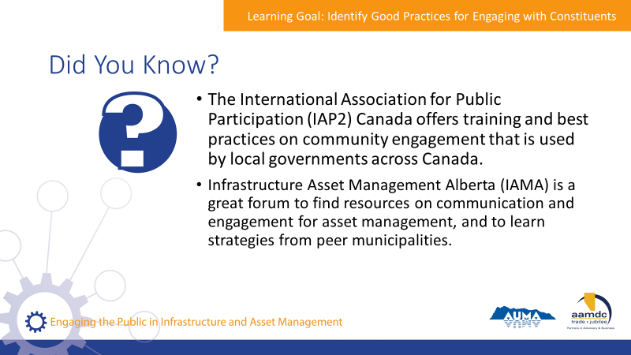 | State:  - Your workbook identifies a few resources where you can go to find out more about engagement.  Read slide.
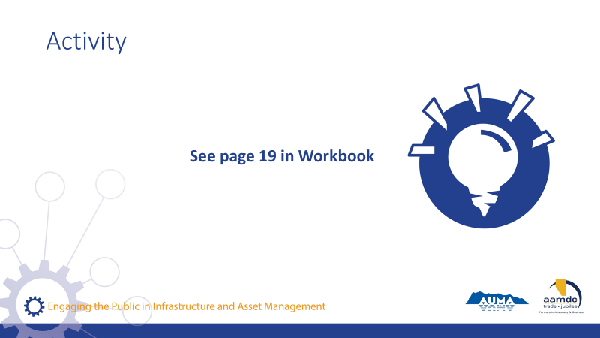 | Activity – page 19 (15 minutes)  State:  - Communications and engagement can take many forms.  - On your table, we’ve placed a number of fun and interesting examples of what it can look like from communities across North America.  - We’re going to introduce each example and provide some context and then we’ll leave you to discuss in your table groups.
State:
- This is a campaign run by the Federation of Canadian Municipalities.
- The purpose was to spread the message across the country.
- The challenge starts with this question "When was the last time you talked about municipal infrastructure with your family, friends or colleagues at work? You might say that you never do, but the fact is many of us talk about infrastructure on a daily basis and don't even know it."
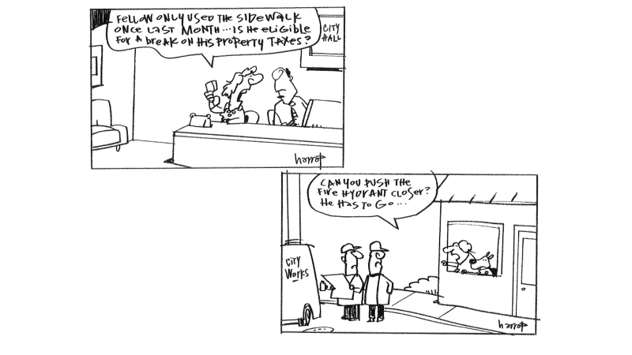 | State:  - This example uses humour to raise sensitive issues in a way that is light and accessible.
State:
- Ads on city vehicles can be used to communicate information about services.
State:
- The City of Denver hired an advertising and design firm to put together this campaign.
- This approach was eye-catching and likely stirred up a lot of conversation from passersby, but it helped the city achieve a 20% reduction in water use five years ahead of schedule.
- Marketing and advertisement can give ideas for how to grab your audience’s attention.
- While it may seem like this tactic is for bigger communities, it can provide inspiration for what you might do on a local level.
State:
- This low-cost awareness-raising campaign brought attention to services that are generally ignored on a daily basis.
State:
- This was a social, pre-election campaign by the council of mayors in southeast Queensland to draw attention to transport upgrades.
State:
- Through this campaign, a professional photographer was hired to capture images of infrastructure and the regular work done by city staff.
- These images helped put infrastructure in a different light to bring it to public awareness.
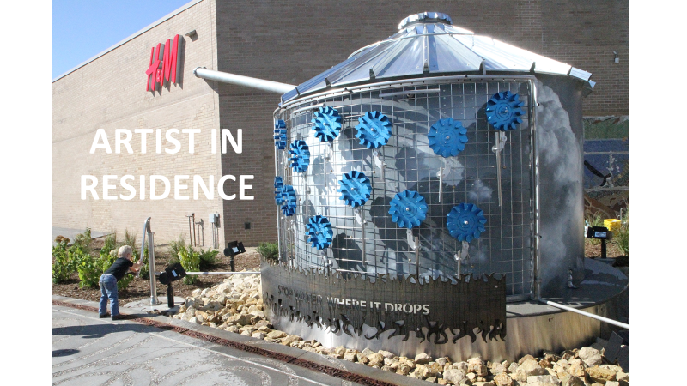 | State:  - Art can be integrated into buildings and infrastructure to draw attention to it and help passersby think about the infrastructure that is meeting their needs.  - This idea can be scaled to many community sizes.
State:
- Infrastructure tours can help tell the story of your community, how it came to be, what are threats and opportunities.
- In New York, a boat tour takes participants to bridges, tunnels, transportation networks, and other major infrastructure.
- What would an infrastructure tour in your community look like? How could you make it interesting for people? Attractive to kids?
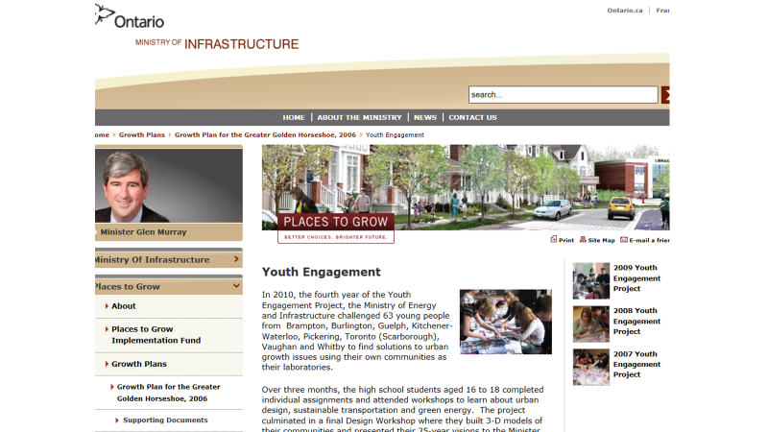 | State:  - You can get different residents in your community to help tell the story.  - For example, engaging kids on planning and infrastructure challenges can lead to some insight into how young people see their community.  - Ideas from participants can be collected and shared publicly to generate a conversation.
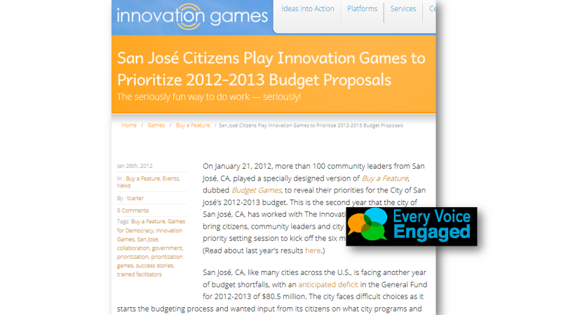 | State:  - Engagement can be fun. In this example, San Jose citizens were invited to participate in design games.  - This was a way to educate the public on municipal services and budgets, as well as get their input.
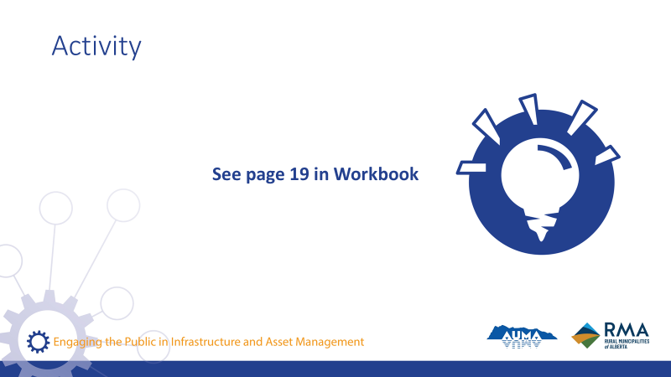 | State:  - In your table groups, discuss the examples and consider the question on page 19 of your workbook: What did these campaigns do to connect asset management with constituent interests.  - Use the space in your workbook to jot down notes and we’ll debrief as a group.  - Let’s go around the room and share what you discussed in your table groups for each of the examples.  - Think about whether you found any ideas particularly effective.  - Did you get any inspiration for what might work well in your community?

Learning Goal: Incorporating Community Input

20 minutes |
Slides | Script
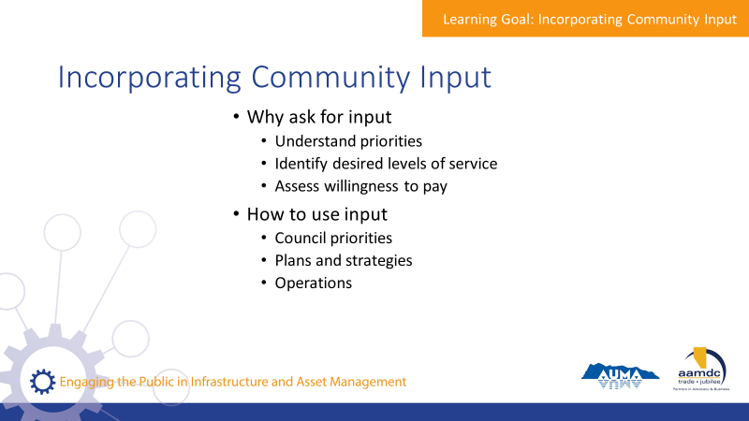 | State:  - When a municipality asks for input from the public, it is usually to:  - Understand priorities  - Identify desired levels of service  - Assess willingness to pay  - Once feedback is collected, the next step is to incorporate it into plans, policies, and decisions.  - Over the next few slides, we’ll be talking about the ways that community input is incorporated into asset management practices.
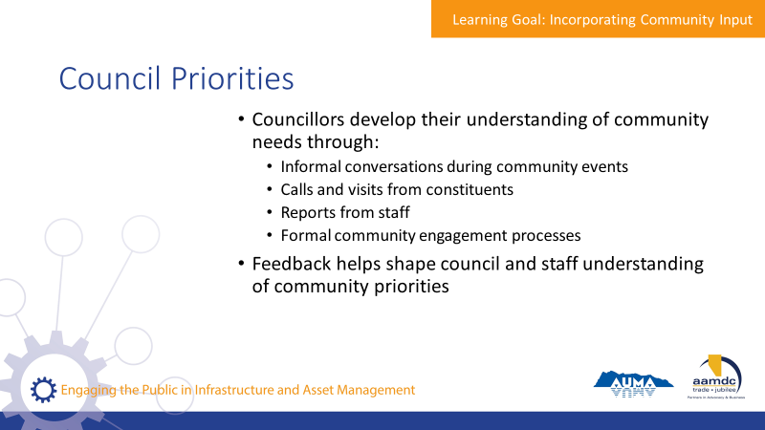 | State:  - Community input can be used to help inform council priorities.  - Councillors develop their understanding of community needs through a variety of means:  - Informal conversations during community events  - Calls and visits from constituents  - Reports from staff  - Formal community engagement processes  - The feedback they collect helps shape council and staff understanding of community priorities.
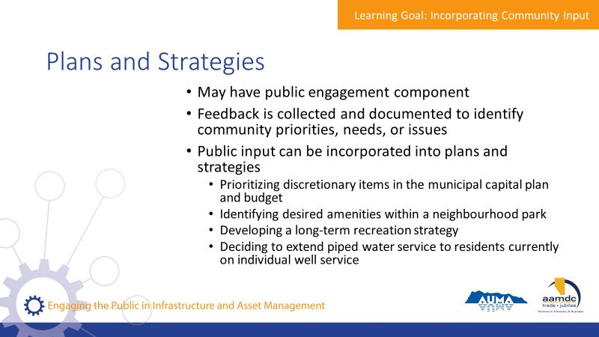 | State:  - Municipalities have a wide range of plans and strategies in their operations.  - Some are long-term and high-level, while others are detailed and specific in scope.  - Municipalities often identify the levels of service they will provide in their plans and strategies.  - Plans and strategies should be integrated with a financial plan that identifies how the municipality will pay for those service levels.  - Because many plans and strategies consider service levels and costs, as well as other community priorities, many are developed with a public engagement component.  - Feedback from the public is collected and document to identify community priorities, needs or issues.  - Formal engagement methods are used in the process of developing plans and strategies to provide structure to how feedback is collected, and to communicate to the public that how their input will be used.  - It can be used to prioritize:  Read slide.
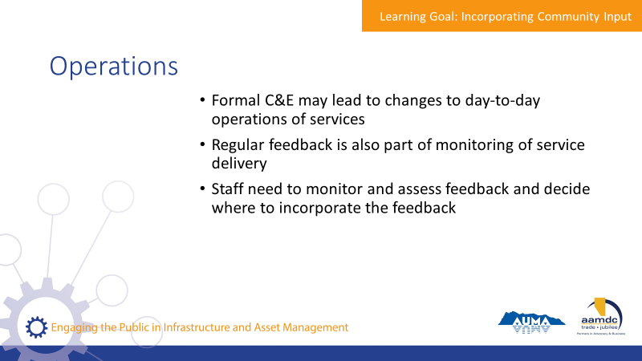 | State:  - Formal engagement that is incorporated into the development of plans and strategies can result in changes to day-to-day operations of services.  - But this is not the only way that feedback from the public impacts operations.  - Regular feedback, including through formal complaints, is part of the monitoring process of ensuring that service delivery is working and meeting needs.  - Sometimes, a municipality only learns that something isn’t working when a constituent complains about it.  - For example, a major storm can create potholes. But the municipality may not find out of a particular pothole until someone contacts them to report it.  - Some complaints can be responded to immediately without impacting overall plans, budgets, or staff resources.  - Other complaints may not be so easy to respond to and may impact budgeting or planning processes.  - Staff will need to monitor and assess feedback and determine how to best act on it.  - For example, a few complaints about public washrooms facilities in a particular park on a specific day can be dealt with quickly by staff.  - However, ongoing complaints about public washrooms may signal that additional staff resources are needed to increase the frequency of inspections and cleaning.
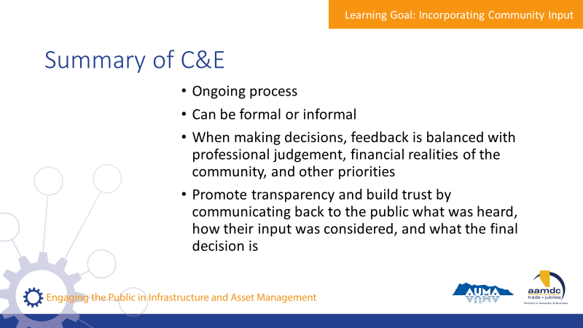 | State:  - In summary, communications and engagement are part of an ongoing process.  - They can be formal or informal, depending on what is needed.  - When making decisions, public feedback is considered together with professional judgement, financial realities, and other priorities.  - The municipality can promote transparency and help build trust in the community by communicating back to the public what was heard, how their input was considered, and what the final decision is.

Learning Goal: Monitor for Success

20 minutes |
Slides | Script
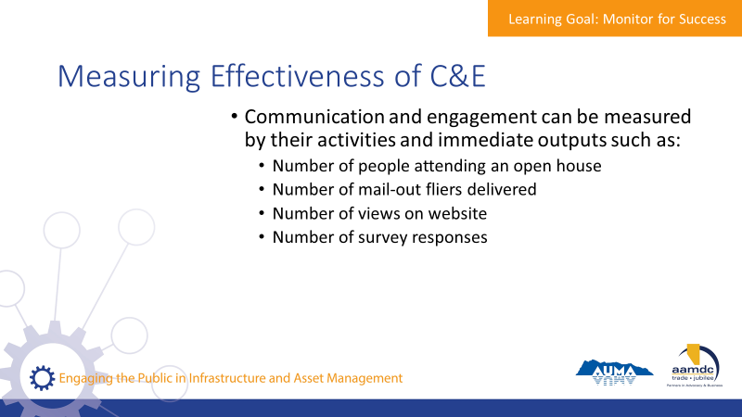 | State:  - Throughout this course, we’ve tried to emphasize that communication and engagement is not a one-size-fit-all process.  - In every community, there are practices that work better than others.  - While good practices can help give you an idea of what you can do, each approach needs to be tailored for your community and for the local context.  - There are different ways to monitor the effectiveness of you communications and engagement.  - For example:  - Number of people attending an open house  - Number of mail-out fliers delivered  - Number of views on a website  - Number of survey responses  - These types of measures can show how widely your message is spreading.  - But they don’t necessarily tell you how well the messages are getting across, which is the ultimate goal of communication and engagement.  - The impact of your efforts are harder to measure and sometimes take more time and sustained effort to achieve.
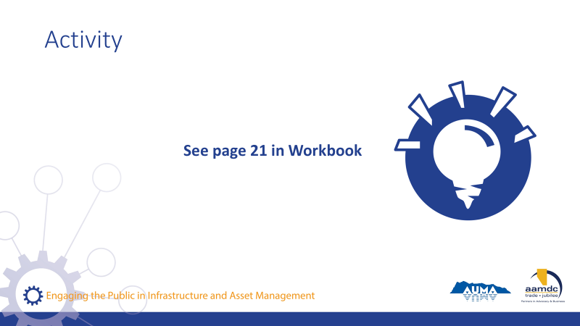 | Activity – page 21 (5 minutes)  State:  - Take a moment to think: How do you know if you’re successful in getting your message across?  - There is room on page 21 of your workbook to jot down your thoughts, but let’s go around the room.  Write down answers for group to see.  Ideas for answers:  - Media coverage of engagement accurately reflects messaging.  - Constituents are able to describe why certain decisions have been made, even if they are unhappy about the final decision.  - Constituents are regularly attending engagement opportunities.
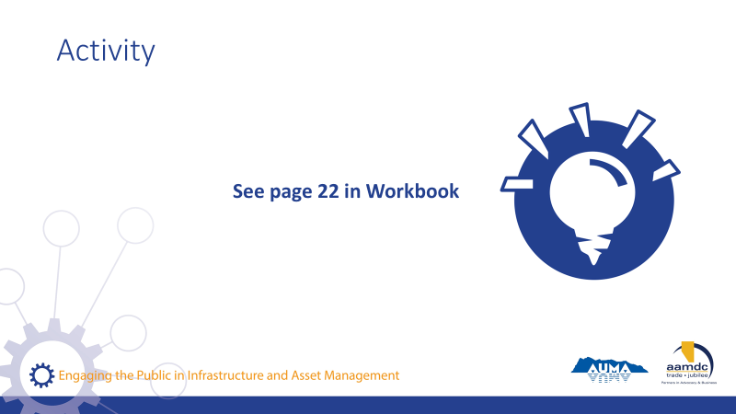 | Activity – page 22 (10-15 minutes)  State:  - Let’s all turn to page 22 of the workbook.  - In your table group, image an ideal community where the public is well-informed, and the municipality is able to effectively obtain public input on important and relevant matters.  - Discuss this scenario and answer the questions on page 22 and 23.  - We’ll regroup and discuss altogether.  Debrief as group.

Learning Goal: Concluding Remarks

10 minutes |
Slides | Script
State:
- Well, you’ve made it!
- Here we are at the end of the course.
- I hope you found today full of learning, good conversation, and shared insight. I want to thank you for joining us.
- Remember, today is just a start.
- Together, we’ve laid the foundation, but we hope that you’ll continue to learn, ask questions, and participate in other opportunities to expand your knowledge of communications and engagement in asset management.
- Throughout the workbook, and at the back, you can find the glossary and a list of resources if you ever need to reference something you learned in this course.
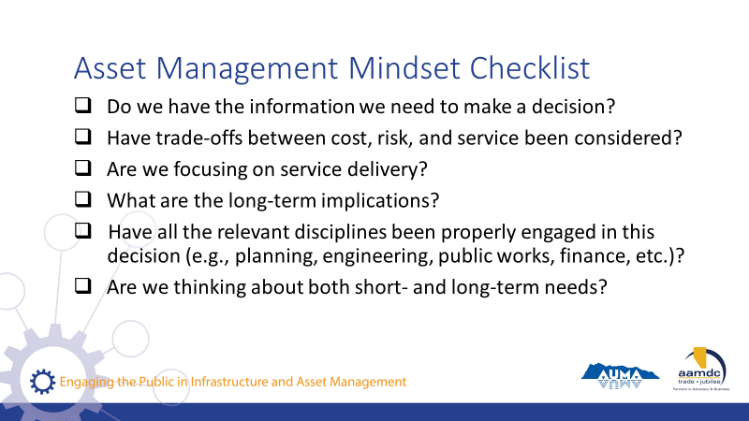 | State:  - If you got anything out of today, we hope that it was an understanding of how an asset management mindset can support you in your role as an elected official and steward of community well-being.  - If you’re ever stuck, start by asking yourself some questions:  Read questions on slide.  State:  - All of these questions apply to the integration of climate change and asset management.
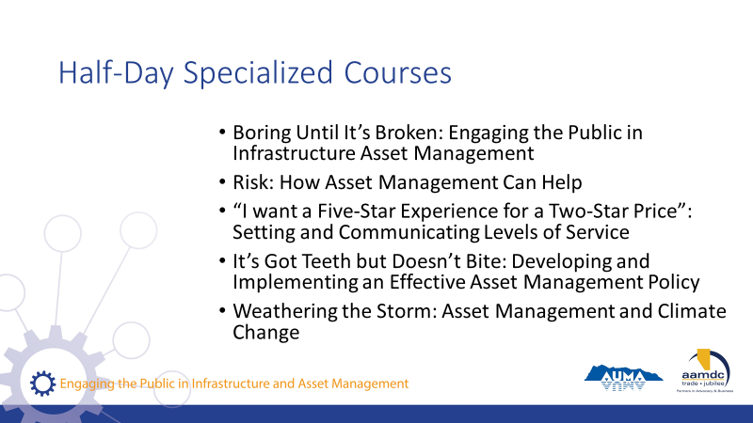 | State:  - AUMA and RMA offer five half-day courses as part of these series on specific topics related to asset management.  Read courses on slide.  - If you want to find out more, talk to us after class.
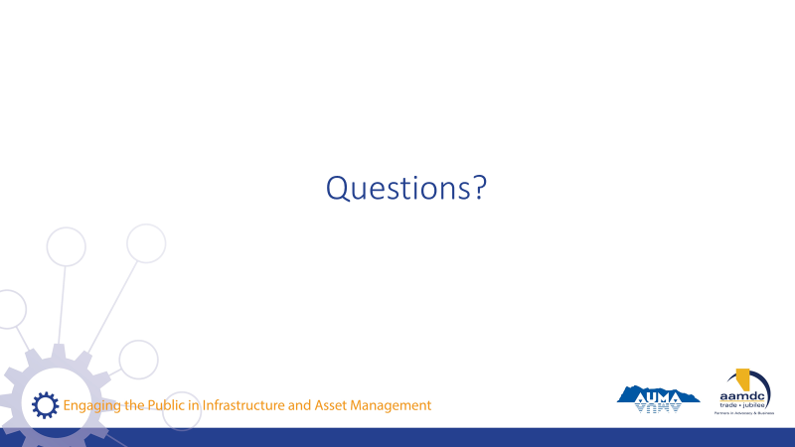 | State:  - Before we leave for the day, does anyone have any remaining questions about anything we covered?
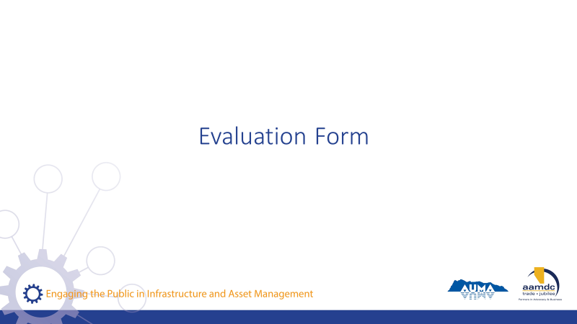 | State:  - Before you leave today, we would really value getting your input on this course.  - Your input will help us to understand how the course helped you (what worked for you) and where we can be making improvements.  - Thanks for taking about 10 minutes to provide your feedback. Once completed, you can leave your forms on (pick a central location for all forms so they remain anonymous).

NOTES

