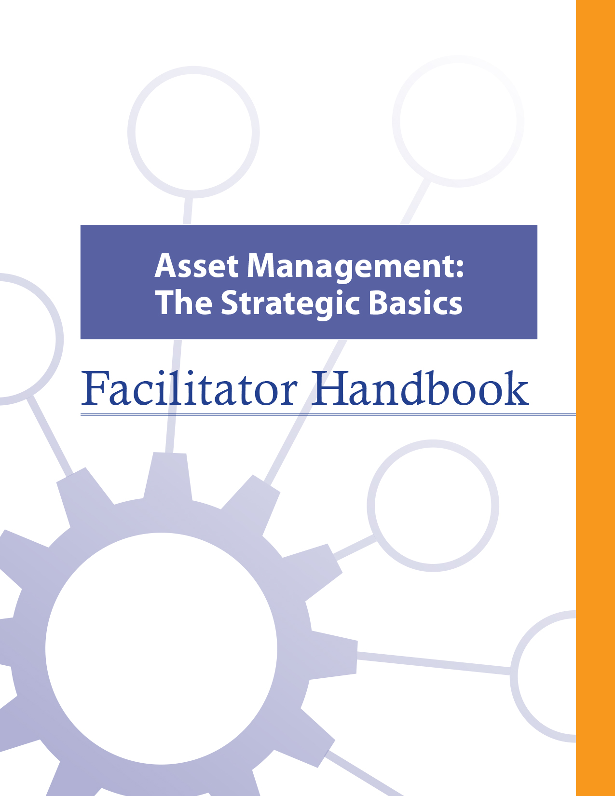
Cover Page

About the FCM
The Federation of Canadian Municipalities (FCM) has been the national voice of municipal government in Canada since 1901, advocating for the needs of municipalities and their citizens. FCM’s membership includes large cities, small urban and rural communities, and 20 provincial and territorial municipal organizations.

About AAMDC
The Alberta Association of Municipal Districts and Counties (AAMDC) is an independent association representing Alberta’s 69 counties and municipal districts. Since 1909, the AAMDC has helped rural municipalities achieve strong, effective local government.

About AUMA
Founded in 1905, the AUMA represents 269 urban municipalities including cities, towns, villages, summer villages, and specialized municipalities. AUMA works with federal and provincial governments and business and community stakeholders on a broad range of issues to strengthen the economic, social, cultural, and environmental vitality of its member municipalities.

This initiative is offered through the Municipal Asset Management Program, which is delivered by the Federation of Canadian Municipalities and funded by the Government of Canada.
fcm.ca/assetmanagementprogram

TABLE OF CONTENTS

How to Use this Facilitator Handbook 1
Characteristics of Adult Learners 2
Agenda 6
Introductory Remarks 7
MODULE 1 – Define Asset Management 10
Learning Goal: Define Asset Management 10
Learning Goal: Articulate the Benefits of Asset Management 13
Learning Goal: Recognize Trade-Offs in Asset Management Decision-Making 19
Learning Goal: Describe the Asset Management Process 25
MODULE 2 – Fulfill the Role of the Elected Official in Asset Management 31
Learning Goal: Identify the Role of Elected Officials and Other Stakeholders 31
Learning Goal: Use an Asset Management Mindset 35
Learning Goal: Articulate the Role of an Elected Official in Providing Leadership on Asset Management 38
Learning Goal: Effectively Use Data and Information 40
Learning Goal: Understand and Follow the Asset Management Process 44
Concluding Remarks and Evaluation Form 47

How to Use this Facilitator Handbook
The Asset Management Course Facilitator Handbook was created to be a resource for the professionals who will be instructing the course on behalf of the AAMDC and AUMA. The Facilitator Handbook is intended to help instructors to provide consistency, and to facilitate the course effectively, within the instructional time available.

How to read the guide:
- The facilitator script and instructions are provided in the right column.
- Thumbnails of the slides corresponding to the script are in the left column.
- The facilitator’s script appears in normal type.
- Additional notes to facilitators appear in bold print.
- Sample responses, discussion points and answers for participant activities appear in italics.

Characteristics of Adult Learners
While we may act like it sometimes, adults are not just big kids. And, we don’t want to be taught like children. As adults, we learn in a very different way than our shorter, younger (maybe even thinner) selves. When we think about a typical learning environment, many of us recall past school days. During those times, our very identity revolved around being a student.
For most of us, the model we have for instructing comes from the teachers who taught us back in the day. However, the teaching techniques that worked for our grade eight English teacher may not be as appropriate for those of us now instructing adults – adults who are also our colleagues and peers. It is important for facilitators of adult education to understand how adults learn and to incorporate teaching principles and strategies that will meet the unique needs of adults and foster the most positive, engaging and productive learning environment possible for them.
What is so different about adults and how can we, as training professionals, incorporate instructional techniques that respect those differences? Below are some generally accepted insights that you may find helpful.

Adults want to have control over their learning
We adults tend to be self-directed. We have work, family and community responsibilities that require us to exercise some level of competence and control. In fact, we can get downright resentful when others take away our right to make choices around our own affairs. This is true when it comes to our learning experiences -- we typically need to exercise some control here, too. In fact, take away our sense of control over how and when we engage in formal learning and you will likely meet some resistance.

What’s a facilitator to do?
- Include adult learners in the planning of their learning (engage them in needs assessments and encourage their input on course objectives & content wherever possible).
- Encourage self-assessment and self-evaluation (rather than instructor-based evaluation).
- Establish a peer relationship with learners rather than the traditional hierarchical one.
- Make yourself available to adult learners outside of the formal learning environment if possible.

Adults, more so than youth, draw upon their experiences as a resource in learning
Been there, done that. Adults have a wealth of past experiences simply because we’ve lived longer than youth. As learners, our past experiences are important resources that we draw on. Adults tend to link new learning to prior learning (much of which is rooted in life experience). Learning is all about accepting and applying new ideas and concepts. For adults, that process often happens within the context of how the idea or concept “fits” with what we’ve already experienced.

What’s a facilitator to do?
- Take time to get to know the experiences of your adult learners and be intentional about helping them link new concepts and ideas with prior learning or experiences.
- Encourage open discussion on how new concepts and ideas being presented fit with the experience of learners.
- Encourage learners to share their experience for the purpose of teaching others. Ask versus tell. Using questions can draw out the information you want to focus on and is an effective way to encourage adult learners to apply their own skills and experience to facilitate their learning.

Adults tend to be more motivated in learning situations than youth
When adults find themselves in a formal learning environment, most times it’s because they want to be there. Adults are not typically motivated by gold stars or good report cards. Instead, they want a learning outcome that can be put to use immediately in concrete, practical and self-benefiting ways.

What’s a facilitator to do?
- Don’t spend a great deal of effort trying to motivate adult learners. Rather, see your role as facilitating the learning they are ready to experience.
- Ensure teaching is relevant to what learners want to learn and what they will be able to use back on the job.
- Accept that people will learn at different rates and in different ways. Some will learn by being told, others will learn by doing. Still others will need to be shown. Use a diversity of teaching methods to ensure your learners stay motivated to learn.

We’re generally more pragmatic in learning than youth
Adults are typically more interested in problem solving than information gathering. Learning “theory,” which must be stored away for future use, can be frustrating and seem irrelevant for many adult learners. Especially for adults, learning becomes complete when we put into practice what we are attempting to learn.

What’s a facilitator to do?
- Using job-related case studies and hands-on exercises and activities will help learners to immediately use what they’re learning in a problem-solving situation. The more often we use what we have learned, the better we can perform or understand it.

Some adults lack confidence in their learning
Some adults who have been away from a formal learning environment for some time may consider the learning “glory days” over. These perceptions can influence how confident they feel during learning situations. Interestingly, research shows that the attention span of the average adult is between 8 and 20 minutes.

What’s a facilitator to do?
- Provide opportunities for learners to receive constructive feedback on how they’re doing (either through guided self-evaluation, constructive input from other participants, or the facilitator’s own observations).
- Present information in a manner that permits mastery in “bite size chunks” with opportunity for hands-on application.

Many adults are more resistant to change than youth
Learning often involves change of some kind. Youth tend to be more idealistic and are often open to change just for the sake of change. However, over the course of being an adult, our experiences around change have not always been good and can lead us to be somewhat resistant to it.

What’s a facilitator to do?
- Encourage learners to explore the “why” of change, not just the “how.”
- Link new concepts to older, understood and accepted concepts.

A group of adult learners will typically be more diverse than a group of youths
A group of adults, more so than a group of youths, will vary a great deal in terms of age, experiences, and backgrounds. Differences can be a powerful resource for learning as adults collaborate together on tasks.

What’s a facilitator to do?
- Allow time for interaction between learners and create opportunities for them to work together in groups to collaborate and share perspectives and experiences.
- Present material in a variety of ways to accommodate a diversity of learning styles.

Agenda
Time | Topic | Facilitator’s Name
8:30 – 8:45 | Introductory Remarks
8:45 – 9:15 | - Define Asset Management
9:15 – 10:15 | - Articulate the Benefits of Asset Management
10:15 – 10:30 | Refreshment Break
10:30 – 11:15 | - Recognize Trade-Offs in Asset Management Decision-Making
11:15 – 12:00 | - Describe the Asset Management Process
12:00 – 1:00 | Lunch
1 :00– 1:30 | - Identify the Role of Elected Official and Other Stakeholders
1:30 – 2:15 | - Use an Asset Management Mindset
2:15 – 2:30 | Refreshment Break
2:30 – 3:00 | - Articulate the Role of an Elected Official in Providing Leadership on Asset Management
3:00 – 3:45 | - Effectively Use Data and Information
3:45 – 4:15 | - Understand and Follow the Asset Management Process
4:15 – 4:30 | Concluding Remarks and Course Evaluation

Introductory Remarks

15 minutes | 8:30 to 8:45 a.m.
Slide | Script
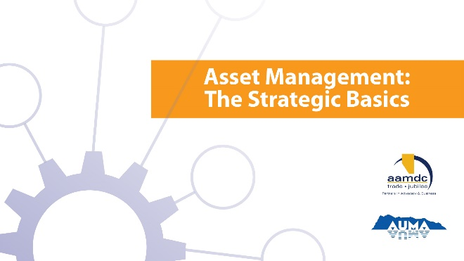
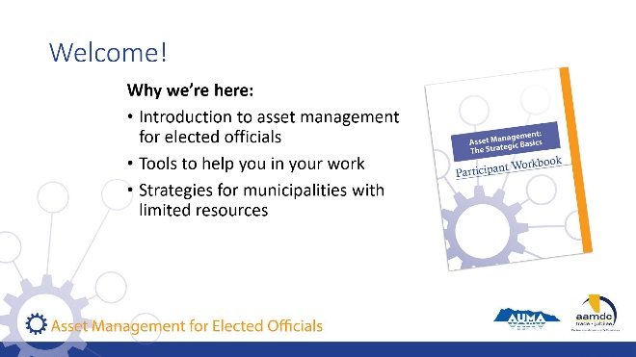 | State:  Welcome to Asset Management for Elected Officials.  Key Introduction Points:  - This course introduces a range of topics on asset management (AM).  - It is designed to equip you with a basic understanding of asset management to support your work as an elected official.  - Some of you already familiar with AM, while for others, this will be new. The course will help build knowledge and give you an opportunity to share your experiences with others.  - Your feedback is important to help adapt the course to serve the needs of elected officials. Please share your feedback throughout the course and fill out the evaluation form at end.
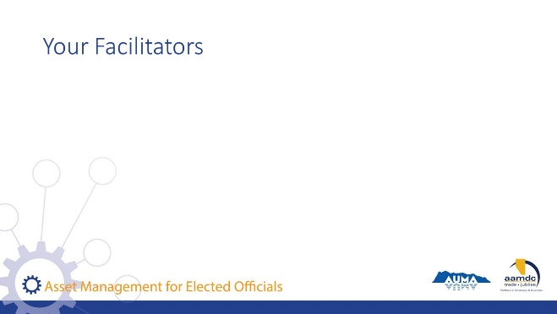 | Facilitator(s) introduce themselves.  Have participants introduce themselves.  Consider the use of icebreaker questions about where participants are at with asset management.
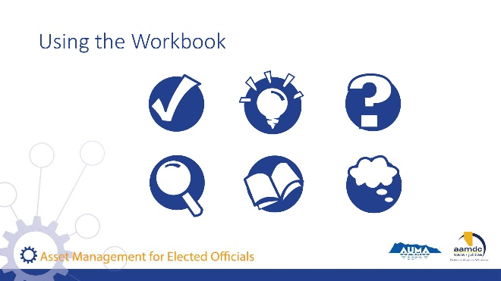 | Review how to use the learner workbook.  State:  Everything we will be covering in the course is contained in your participant workbook. However, we won’t necessarily be talking about all of the content in the workbook. I would encourage you, at some point, to read it over from start to finish.  We have also included a number of recurring icons intended to help you find relevant information in your workbook easily.  As icons appear (with click) on slide, review what each means and how to use it.  State:  The course is based on achieving specific learning goals. This icon identifies the learning goals, so you can be thinking about whether you are achieving them  This icon lets you know we’ve added an interesting fact or additional information related to the course material that we may not specifically cover in our discussion.  When you see this icon, it means we have included a reference to additional information on the topic that you can review at a later date.  Throughout the course, we will provide opportunities for you to apply your knowledge and share your expertise with a partner through various activities related to what you are learning.  In discussing municipal governance, there are a number of terms that may not be familiar to everyone. We’ve highlighted a few in these Glossary boxes and provided definitions. If you spot a term you aren’t familiar with and we haven’t provided a definition, please let us know by filling out the evaluation form and we will not only address it in this course but will add it to future participant workbooks.  Throughout the course, we want you to be continually thinking about how what you are learning in the course will apply to your role as elected official. For this reason, we’ve created space for you to reflect and record your thoughts on what the course content may mean in your world.
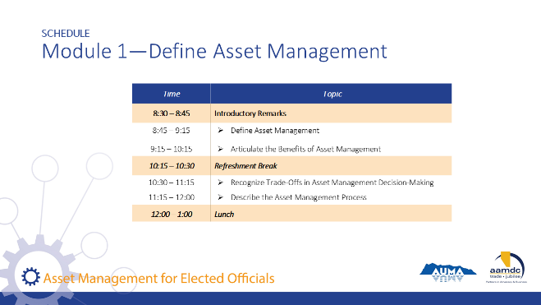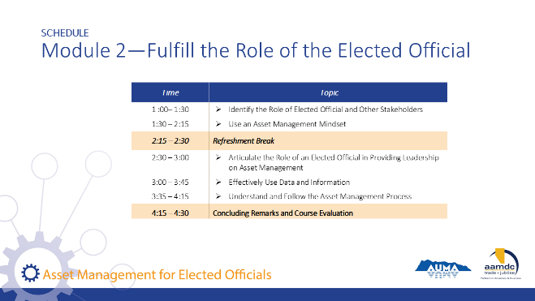 | Review course outline schedule.  State:  As you can see, we will be covering a lot of content today.  Review schedule on slide.

MODULE 1 – Define Asset Management

Learning Goal: Define Asset Management

30 minutes | 8:45 a.m. to 9:15 a.m.
Slide | Script
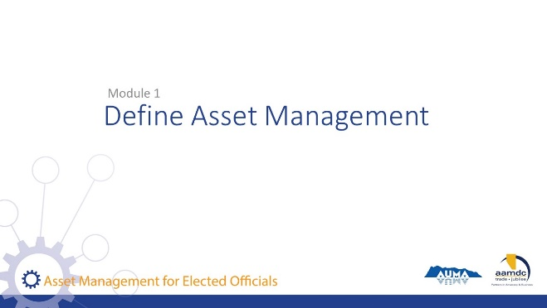 | Introduce Module 1  State:  This course has been designed with specific learning objectives in mind. Learning objectives state what learners should be able to do, after completing a module. So, after completing Module 1, you should be able to:  - Define asset management  - Articulate the benefit of asset management and the role it plays in sustainable service delivery  - Understand the role of asset management in recognizing trade-offs and making decisions  - Describe the aspects of an asset management process and what each is used for  If you don’t feel like you are mastering these learning objectives, or if you have questions about any of the content, we want to encourage you to let us know. Ask questions during the course at any time or see us during the break.  Also, you will get out of the course what you put into it. So please participate fully and if there is anything that may get in the way of your full participation, we want to know that as well.
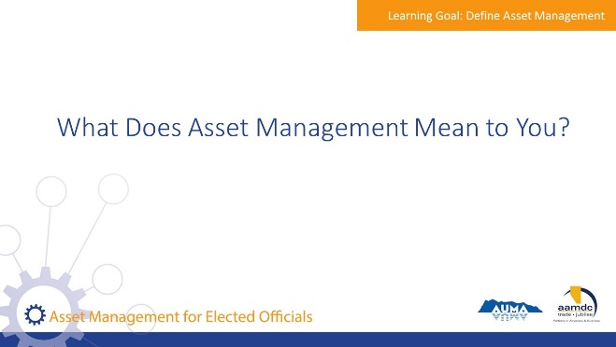 | State:  Let me ask you, when you hear the term asset management, what comes to mind?  Encourage participants to share their thoughts with the large group.
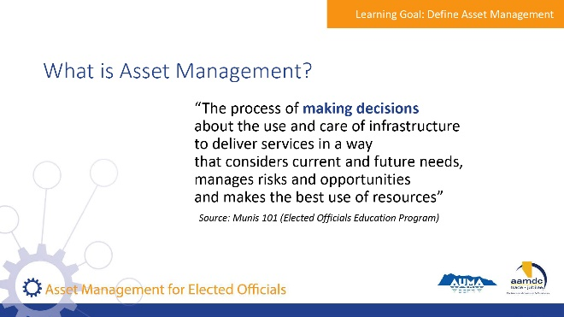 | State:  Municipalities in Alberta are empowered to provide a range of services to their communities through provincial legislation, specifically the Municipal Government Act (MGA). A major component of service provision is taking care of the assets that make those services possible.  An asset, also known as a tangible capital asset (TCA), is a physical component of a system that enables a service, or services, to be provided. For example, pipes are the assets that deliver water service to homes, roads and traffic lights are the assets that make transportation possible, and recreation centres are assets that allow recreation services to be provided to the community.  Municipalities have been managing assets for a long time. However, asset management is more than just managing assets or developing inventories of the assets a municipality owns.  Here’s one definition of asset management that we think captures the essence of what it really is. We took this from the Elected Official Education Program’s Munis 101: The Essentials of Municipal Governance course that many of you took earlier this year.  Review definition from slide.  State:  They key term here is “making decisions”  - Asset management is about using systems and processes to balance cost, risk, and level of service to make informed decisions that make sense for your community in the long run.  - It is not just for large communities. All municipalities make decisions about their assets.  - The systems and processes don’t need to be extensively detailed or expensive; you can start where you are.  - Your municipality likely already uses processes for things like planning and budgeting. Asset management is about updating those processes to ensure they systematically consider the right kind of information and take a long-term perspective.
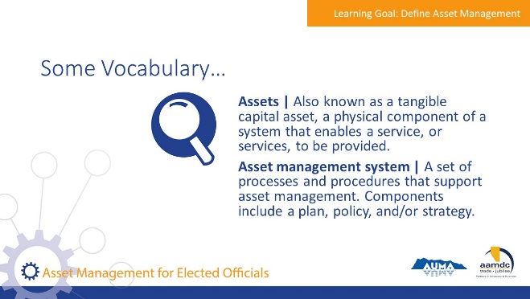 | State:  There are a couple of terms we will be using as we discuss asset management, so we want to make sure we have a common understanding of them before we get into our discussion of asset management.  Review terms on slide.
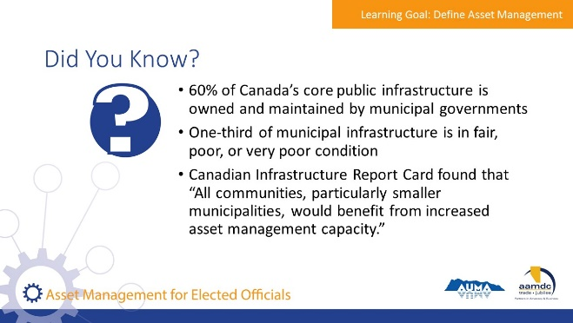 | State:  Here are a few statistics we thought you would find interesting. Do any of these surprise you?  They serve to set the context for why asset management has become increasingly important in Canada.
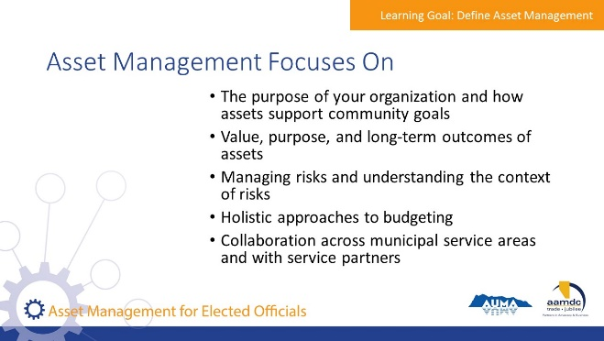 | State: Asset management focuses on things like:  - The purpose of your organization and how assets support community goals  - Value, purpose, and long-term outcomes of assets  - Managing risks and understanding the context of risks  - Holistic approaches to budgeting  - Collaboration across municipal service areas and with service partners  Throughout the course, we will emphasize that asset management is scalable, and that asset management is about the process, not about a database or plan.
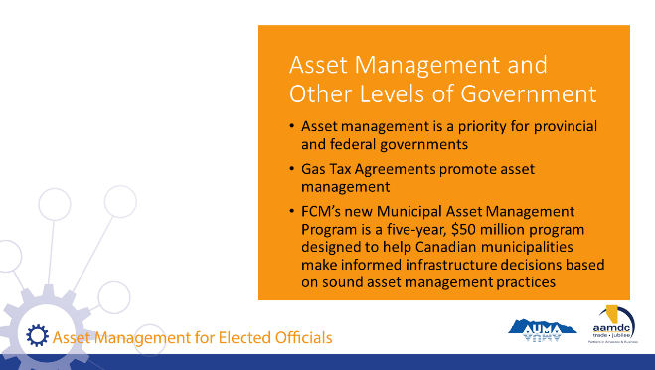 | State:  Asset management is increasingly being prioritized by other levels of government, particularly in the distribution of infrastructure funds, as well as in planning and reporting requirements.  - Federal-provincial Gas Tax Agreements are also promoting asset management practices across Canada.  - In Alberta, the revised MGA requires that municipalities prepare new three-year financial and five-year capital plans. Asset management policies, strategies, and plans support the preparation of these plans.  - The federal government has made $50 million available in grant funding through the Municipal Asset Management Program.
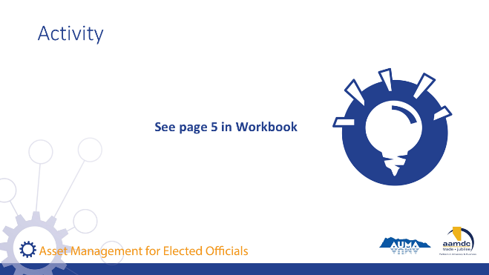 | Activity – Page 5 (8-10 minutes)  State:  Take 2 to 3 minutes and, working individually, record your answers to the three questions in the workbook on page 5.  Debrief Activity  State:  Once you have finished recording your answers, briefly share one of your answers with your table group. Make sure everyone has a chance to share. We will give you 5 minutes so about 1 minute for each person.  Ask for volunteers to offer an answer from their table to the 2nd question “How might an elected official know that a municipality is practicing asset management?”

Learning Goal: Articulate the Benefits of Asset Management

1 hour | 9:15 a.m. to 10:15 a.m.
Slide | Script
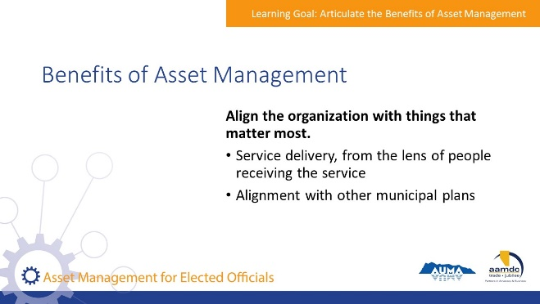 | State:  Asset management helps municipalities deliver services effectively, efficiently, and in a way that protects the long-term interests of the community. It essentially helps you to deliver the services that are important to your community, get the biggest bang for your buck from your assets, and set your community up for success.  Align the organization with things that matter:  - Asset management is about service delivery.  - Effective service delivery means setting priorities and making decisions from perspective of what matters most to constituents.  - It helps reduce duplicate work and unnecessary interruption to constituents’ access to certain services. For example, asset management would help a community prioritize projects that align with the community’s vision and priorities outlined in its Strategic Plan, or help prioritize a water main replacement based on risk to service outages and coordinate such work with road projects to minimize traffic disruption and lifecycle costs identified in the community’s transportation master plan. Asset management should integrate and align with other municipal plans.
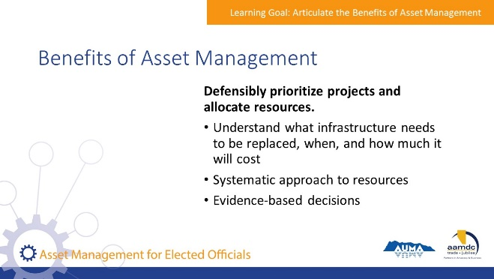 | State:  Asset management helps communities decide what infrastructure needs to be replaced, when, and how much needs to be saved for infrastructure renewal.  Taking a systemic approach supports efficient use of resources and equips a community with strong evidence that can be used to communicate why decisions are made, particularly when the need for investments is unclear or controversial to the public. For example, asset management can be used to help a municipality identify the need for water main replacement throughout the community, and plan for these costs.  It can also be used to evaluate competing priorities, such as a town hall upgrade or the development of a recreation trail.
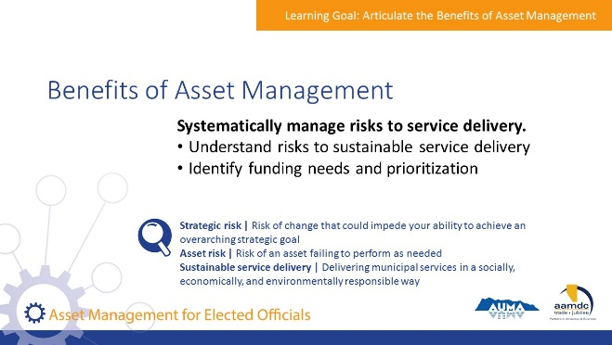 | State:  Asset management supports the management of both strategic risks and asset risks – leading to sustainable service delivery. For example, many communities in Alberta face risks related to their roads. There are risks that specific roads will fail because they are in poor condition (asset risk) and there is an overall concern that deteriorating road conditions will lead to complaints from the public and potential safety issues (strategic risk). There isn’t enough money to fix all the roads, especially given all the other financial demands on the community (also a strategic risk). The level of service for roads is decreasing and there are weight restrictions on some roads with no plans to correct them (risk to service sustainability).  Asset management helps a community identify overall funding needs for sustainable service, prioritize where and when money should be spent repairing roads to appropriately manage risks, identify how much should be saved for long-term maintenance, and understand how to effectively respond to public complaints.
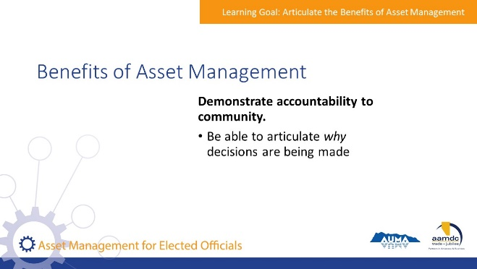 | State:  Asset management establishes a clear and systematic approach to making decisions, prioritizing resources, and planning for the future, which in turn demonstrates municipal accountability. For example, asset management will help a municipality explain to a small (but vocal) group of residents why their road will not be paved – even though other roads in town may be.
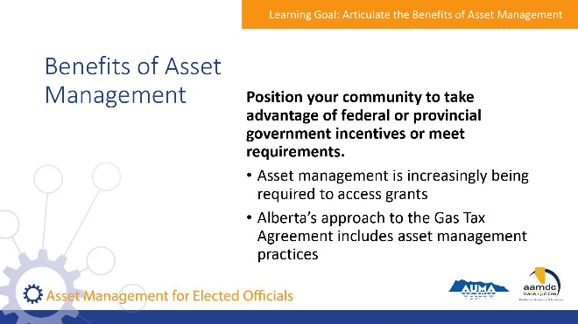 | State:  Your municipality may have opportunity to align with government incentives for asset management. Provincial and federal governments are increasingly looking for indicators that a local government is practicing asset management in grant applications.  The 2014-2024 Gas Tax Agreement between Canada and Alberta included requirements that Alberta develop an approach to asset management. In 2016, the federal government approved Alberta’s approach, which includes:  - Publishing an inventory of current asset management tools and resources  - Supporting the development of new tools that support asset management  - Enhancing existing advisory services and training opportunities  - Assessing existing gaps and expanding tools and resources where required  - Reviewing corporate planning requirements as part of the MGA review
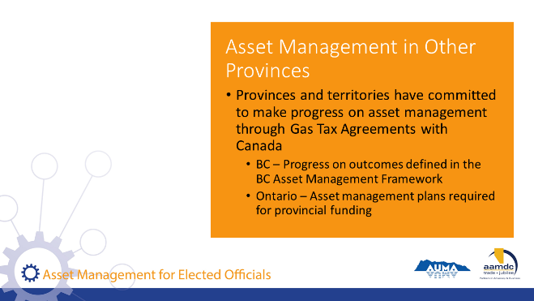 | State:  Each province has committed to making progress in asset management through their respective Gas Tax Agreements with Canada, and each province is choosing their own approach.  - In British Columbia, the emphasis is on making progress on achieving outcomes defined in the BC Asset Management Framework.  - In Ontario, there are requirements to have specific asset management plans that demonstrate their infrastructure funding needs.  The specific provincial requirements may change over time as each province learns what is effective in their context.
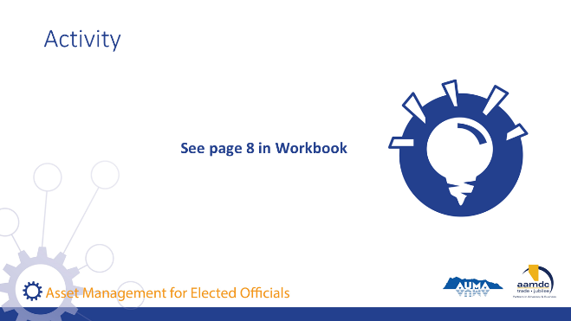 | Activity – Page 8 (20-30 minutes)  State:  We are going to get you working on an activity on page 8 that will help you apply some of these asset management concepts. Before we do, let’s look at a couple of terms that may not be all that familiar. Have a look at the graph on that same page.  Take a moment to consider the information on page 8. Then, working in pairs, complete the questions on page 9.  Be prepared to share some insights with the larger group.
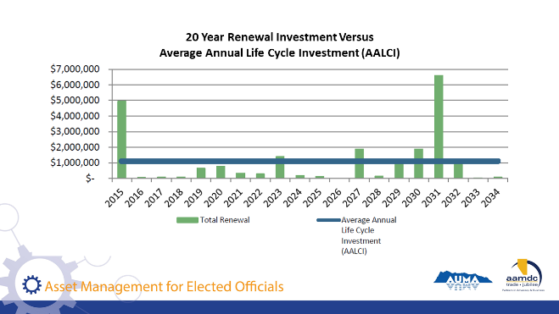 | Explain the graph  State:  Renewal investment  - Is the amount that will be needed to replace or renew existing assets when they are projected to wear out. For example, if a pipe was constructed in 1940 and is expected to have a useful life of 80 years, the full cost of replacing that pipe would be shown in 2020.  - The total renewal cost is shown in green for each year on the graph.  - Total renewal means the total cost of replacing ALL assets in a community that will be at the end of their service life on a particular year.  - It is common to see spikes because often significant infrastructure investments are made at the same time and so all that infrastructure reaches the end of its service life at the same time.  Average Annual Life Cycle Investment (AALCI)  - This is the blue line that stretches across the graph.  - It indicates the average amount that a municipality would save each year in reserves if it is to pay for the replacement of the assets in full at the end of the assets lives. For example, if a segment of pipe cost $80,000 and the pipe is expected to last 80 years, you would theoretically save $1,000 per year for 80 years so you could pay to replace it when its at the end of its projected life.  - The total AALCI for a municipality is the sum of the average for all infrastructure.  - Since it is very uncommon for municipalities to fully fund replacement of infrastructure from reserves, this is more of a theoretical value that is used for communication and planning purposes only.  Debrief:  For each question, ask for a group to share their BRIEF answer to that question (choose a different group for each question).  Some key observations and comments:  - There is a spike in expenditure in the first year. This is the deficit, or backlog. These are all the assets past their useful life.  - There are several years with low expenditure.  - There are high spikes in expenditure in only a few years. This means that many assets were built around the same time and may need to be replaced around the same time.  - Assets will not necessarily fail at the exact end of their expected useful life. However, this graph helps us to understand potential risks and plan for them.  - The AALCI is the theoretical amount a community would save each year if they wanted to pay to replace assets in full when they fail. A community may not be able to afford to do this and may not want to take this approach. But this information should prompt some planning about how to handle failing assets.  - Different assets will have different consequences of failure (and therefore represent different risks). A good question to ask would be to understand what are the risks represented in this graph (i.e. are these spikes generated by failing sidewalks? Or a failing water treatment plant?).
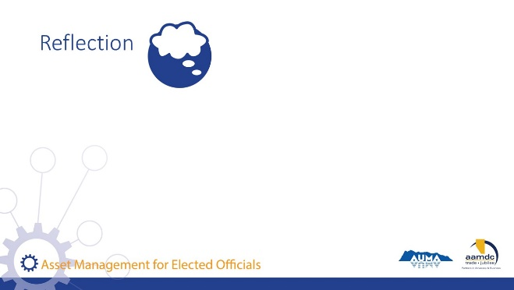 | State:  We want you to have some time to reflect on what all this means for your municipal circumstances. Take 5 minutes and record individually your answers to the questions on page 9.

Break
15 minutes | 10:15 a.m. to 10:30 a.m.

Learning Goal: Recognize Trade-Offs in Asset Management Decision-Making

45 minutes | 10:30 a.m. to 11:15 a.m.
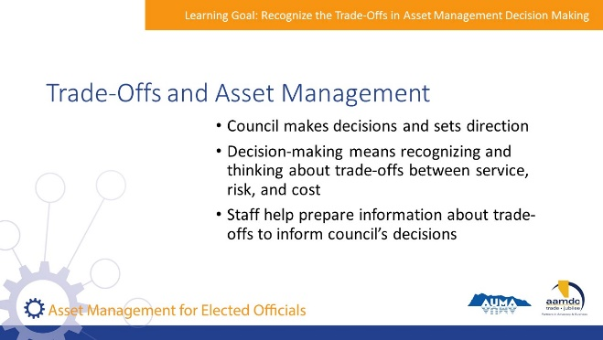 | State:  - It is council’s role to make decisions and set direction.  - Making decisions in a municipal context requires thinking about trade-offs between service, risk, and cost.  - While it is not the role of councillors to prepare information about service, risk, and cost trade-offs, it is their role to request information from staff to support sound decision-making.
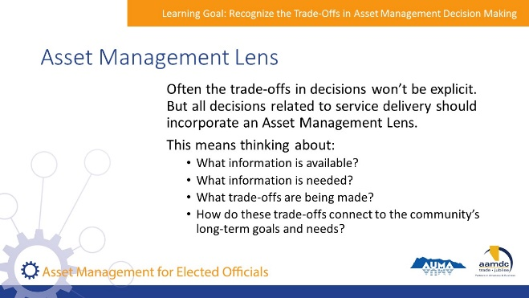 | State:  - Council needs to request and assess the information about trade offs using an asset management lens.  - That means thinking about:  - What information is available?  - What information is needed?  - What trade-offs are being made?  - How do these trade-offs connect to the community’s long-term goals and needs?
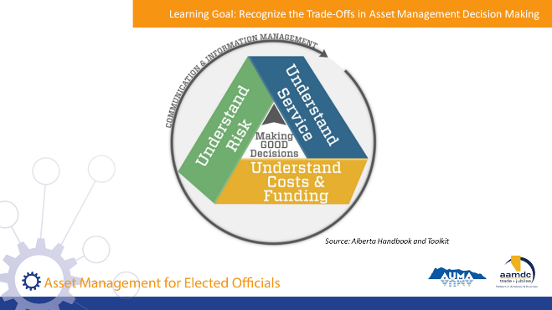 | State:  To understand the importance of having an asset management mindset, we’re going to review service, risk, and cost considerations – what these are and how they may impact asset decisions – and then work through some trade-off scenarios together.  Explain the graphic on slide.  State:  Sustainable service delivery is at the centre of asset management. Having asset management processes in place will help you to be clear on what services you’re providing, at what level, and how the service needs will change over time. Constituents are the recipients of services and will therefore have an important role in determining what services will be delivered and to what level. It is important that constituents are engaged somehow in these decisions – either directly or through their elected officials. However, decisions about service delivery should always be made in the context of the cost of delivering services and the associated risks.  Over the next few slides, we’ll review some of the questions you may think about or ask when considering the service your community provides.
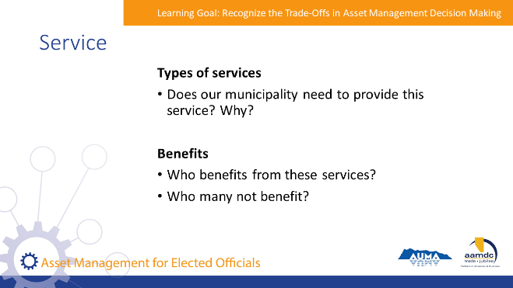 | State:  - Does our municipality need to provide this service? Why?  - Who benefits from these services?  - Who many not benefit?  With participants, review examples in the workbook on page 11.
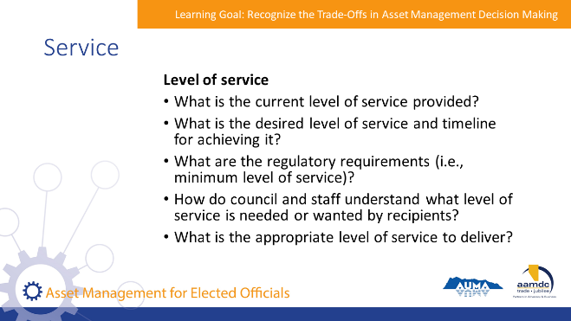 | State:  - What is the current level of service provided?  - What is the desired level of service and timeline for achieving it?  - What are the regulatory requirements (i.e., minimum level of service)?  - How do council and staff understand what level of service is needed or wanted by recipients?  - What is the appropriate level of service to deliver?  With participants, review examples in the workbook on page 11.
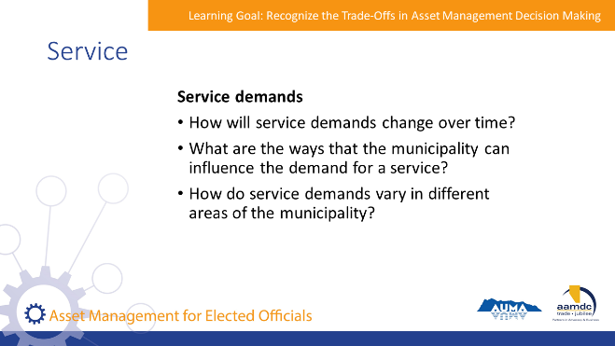 | State:  - How will demands for our services change over time?  - What are the ways that the municipality can influence the demand for a service?  - How do service demands vary in different areas of the municipality?  With participants, review examples in the workbook on page 11.
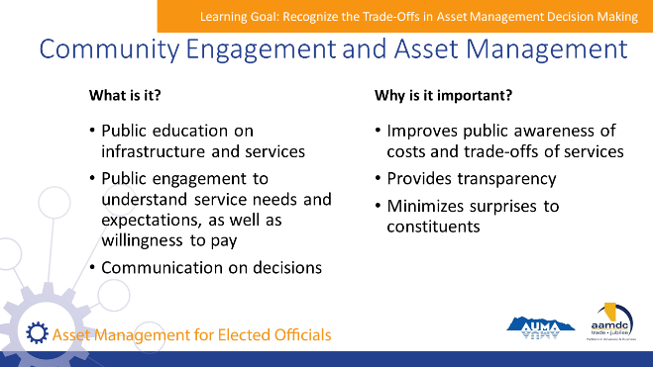 | State:  Most often, infrastructure assets are invisible to the public until something goes wrong. You don’t notice the quality or condition of your roads until there is a pothole, or how much water you use until there are water restrictions in place. Community engagement is an important part of asset management. Input from community members helps council and staff understand what service levels are needed and it helps the public understand the reasons behind priorities and investments.  What is it?  - Informing the public on infrastructure and the costs of service delivery.  - Being transparent about investment decisions and levels of service.  - Considering public input and expectations in the setting of levels of service and understanding willingness to pay.  Why is it important?  - Minimizes surprises to constituents.  - Demonstrates transparency of decision-making and prioritization – which can improve trust.  - Informing the public on how services are delivered, and the trade-offs considered can increase the willingness to pay.  - The AAMDC and AUMA will be offering a half-day course specifically focused on public engagement in relation to asset management. If you are interested in that course, please contact the AUMA or AAMDC.
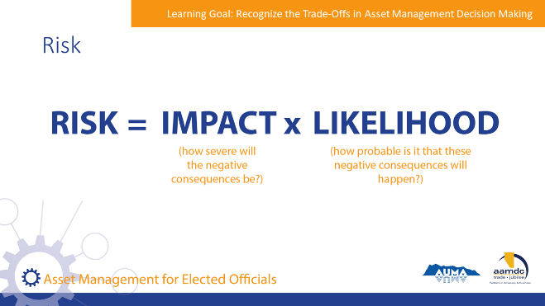 | State:  Risk can be expressed in a simple calculation that sounds something like this:  Risk equals the impact (how severe will the negative consequences be) times likelihood (how probably is it that these negative consequences will happen).
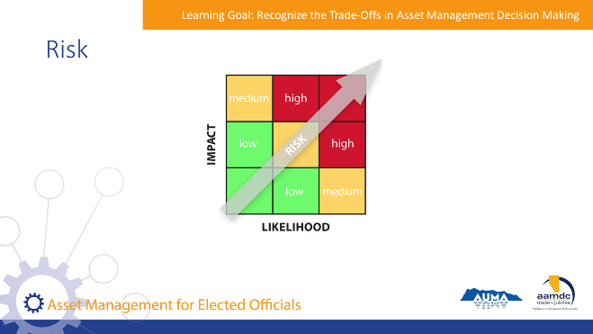 | State:  This matrix is used to plot the level of risk that might be associated with a particular action or event.  Here’s how it works:  Ask participants for a verbal example and show where the risk will fall on the matrix.
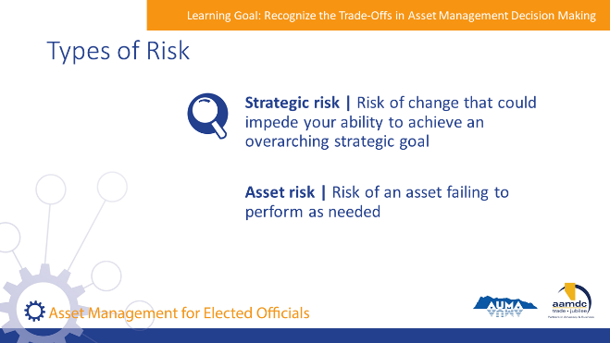 | State:  When we are considering asset management, there are two types of risk:  - Asset risk describes the risk of an asset failing to perform the way you need it to deliver a service. For example, a pipe bursting, roadway washing out, or lagoon reaching capacity all describe types of asset risks.  - Strategic risk describes a change that would affect your ability to achieve municipal objectives. For example, the Public Works manager retiring without a transition plan in place, a declining revenue base, or changing regulations are strategic risks.  Climate change is an example of both asset and strategic risk.  - It is an asset risk because changes to temperature and weather patterns may impact the ability of your infrastructure to perform as it was intended to. For example, increased rainfall may overwhelm your stormwater system because it was built for a different capacity and range of events.  - Climate change is also a strategic risk because it changes the assumptions under which services are delivered, which may force your community to draw resources away from some goals towards others. For example, if your community’s water source is becoming compromised by hotter, drier conditions, resources may need to be shifted to find another water source or better secure the existing one.
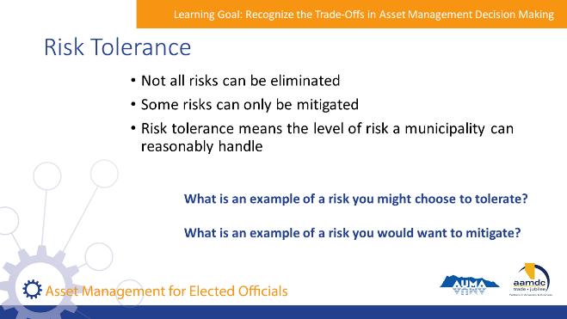 | State:  Managing risk is not always as straightforward as eliminating risk, and every community and asset has a different level of risk tolerance.  - In some cases, a community can mitigate risks but not eliminate them altogether. For example, a community that faces drought conditions each summer can enact water conservation measures and educate the public, but may not be able to prevent the need to enforce water restrictions.  - In other cases, the level of risk may be manageable, but a municipality may choose to tolerate the risk because other priorities are more urgent. For example, a side road in poor condition may be a nuisance for the small portion of the population that uses it, however, investment in repairing the road may be delayed to pay for the cost of repairing a burst pipe.  Asset management involves the consideration of a community’s risk tolerance: the level of risk the municipality can reasonably handle.  - Attempting to reduce risk as much as possible is prohibitively expensive, and unnecessary.  - Municipalities and their constituents understand that things aren’t going to be perfect 100% of the time – but the important things need to be pretty good most of the time.  - Your risk tolerance will be informed not just by the magnitude of the risk (the consequence it will have and the likelihood that it will happen) but also the cost of managing or reducing the risk. This is an example of a trade-off between risk and cost.
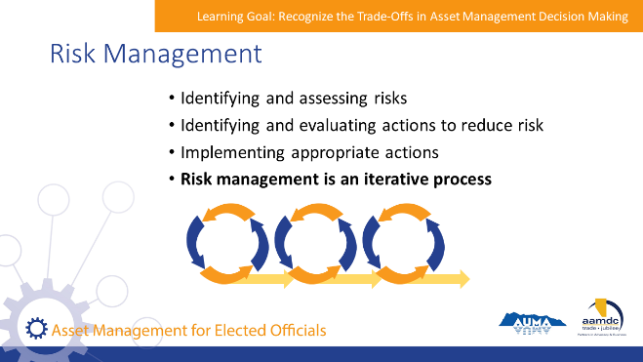 | State:  Risk management refers to the process of identifying and assessing risks, identifying and evaluating actions that can be taken to reduce risk, and implementing the appropriate actions.  Risk management is an iterative process, meaning that the desired result is achieved through repeated efforts, rather than through a single action.
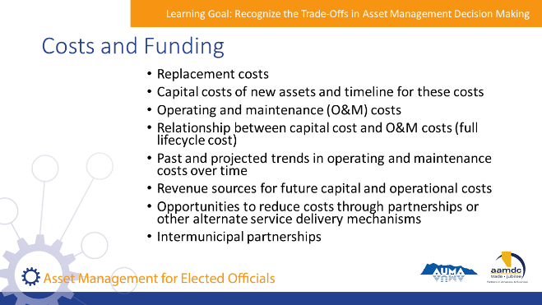 | State:  We intuitively understand that there is a connection between cost, level of service, and risk, but we often limit our considerations to the immediate situation. When considering cost in trade-offs, it’s important to think about:  - Replacement costs of current assets and the timeline for these costs  - Capital costs of new assets and timeline for these costs  - Expected operating and maintenance costs for current and new assets  - Actual operating and maintenance costs for current assets  - Relationship between capital cost and O&M costs (full lifecycle cost)  - Past and projected trends in operating and maintenance costs over time  - Revenue sources for future capital and operational costs  - Opportunities to reduce costs through partnerships or other alternate service delivery mechanisms  - Asset management for assets funded through intermunicipal partnerships  There is no ‘right answer’ when it comes to evaluating trade-offs. What is important is that there is information and a process available to consider the trade-offs effectively for today and the future.
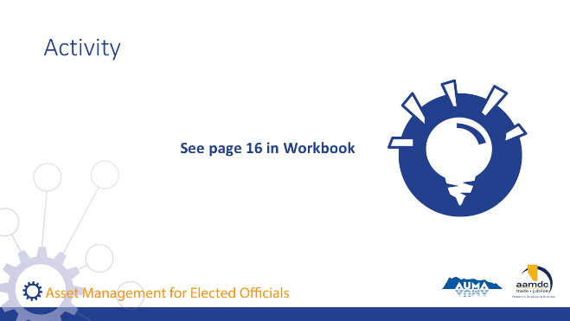 | Activity – Page 16 (15 minutes)  State:  Please turn to page 16 in your workbook. You’ll find an exercise there that provides a number of scenarios that a municipality might face. Working in your table group, choose two or more of the scenarios to work on. For each scenario, identify the service, risk and cost considerations for each. We will ask a few tables to share their results when you are finished.  Note: Go through the first scenario together as a large group if participants need further instruction about what to do.  Debrief:  Identify a table that completed Scenario 1. Ask them to BRIEFLY share their answers with the larger group. Repeat for Scenarios 2 to 4. Engage larger group in the discussion asking questions like:  - Did other groups identify other trade offs?  - What are some other considerations a municipality might consider that could impact the decision, beyond service, risk, and cost?  A point to make for this exercise is that although municipalities should identify the same considerations, they may come to different conclusions about what to do. As mentioned above, there is no “right answer” when it comes to evaluating trade-offs. When making these decisions in real life, there is additional information that would be taken into consideration, such as other possible sources of funding, priorities of the community, and alignment with long term community vision and plans.

Learning Goal: Describe the Asset Management Process

45 minutes | 11:15 a.m. to 12 p.m.
Slide | Script
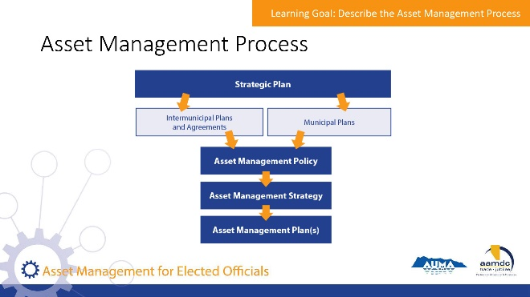 | State:  Asset management isn’t just about planning and policy documents. However, as part of a robust process, planning and policy documents can support decision-making by documenting community goals related to assets and providing a roadmap for how to achieve these goals.  We’re going to spend some time reviewing the different tools available to guide asset management and how these are used. For reference, examples of policies, plans, and strategies can be found in the Resources section.  This slide shows the general hierarchy of plans that lead into the various components of asset management.  Your municipality doesn’t need to have all of these plans and documents to be “doing” asset management, although these will help with taking a systematic approach. You can start with what you have and build towards developing these documents over time. It’s also not these documents/tools that matter, it’s the implementation of them that is important.  Review slide graphic on slide.
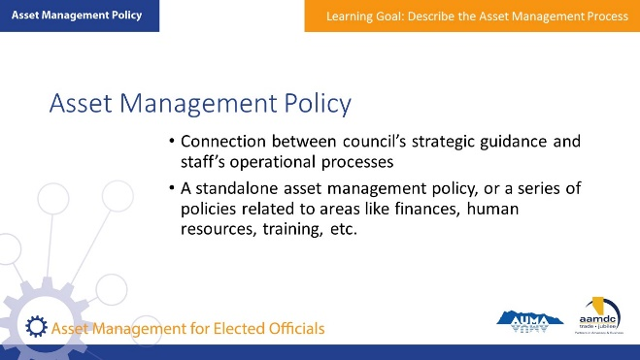 | State:  An asset management policy is used as the connection between council’s strategic guidance and staff’s operational processes.  Asset management as a practice touches on many parts of a municipality’s operations, and so there are various ways a municipality may choose to adopt policy related to asset management.  A municipality may choose to develop a standalone asset management policy, or may choose to develop or update a series of policies related to areas like finances, human resources, training, etc.
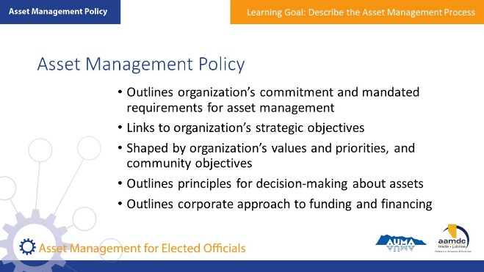 | State:  Policies related to asset management should:  - Outline an organization’s commitment and mandated requirements for asset management  - Link to the organization’s strategic objectives  - Be shaped by organization’s values and priorities, as well as community objectives  - Outline principles to guide decision-making about assets (for example, incorporate lifecycle costing, adopt a risk-based approach to setting priorities, etc.)  - Outline the corporate approach to funding and financing asset acquisition, renewal, and operations and maintenance  Council’s role is to provide the direction and strategic guidance that is captured in the policy.
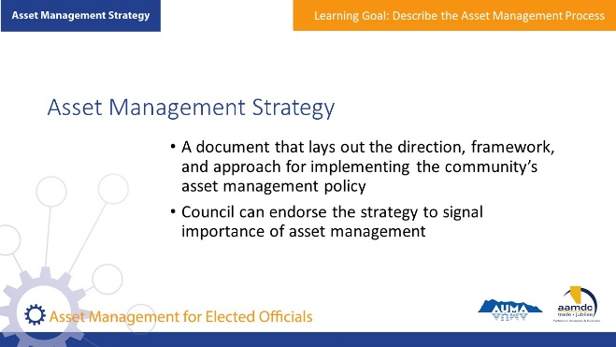 | State:  As part of developing and maintaining asset management practices, council may be asked to endorse an asset management strategy. The asset management strategy is primarily for staff use, but council may provide input on the document. Council’s endorsement is an important signal that the implementation of the strategy is important to the municipality. Implementing the strategy may require some re-alignment of staff and financial resources, so it is important that council knows about the asset management strategy being adopted
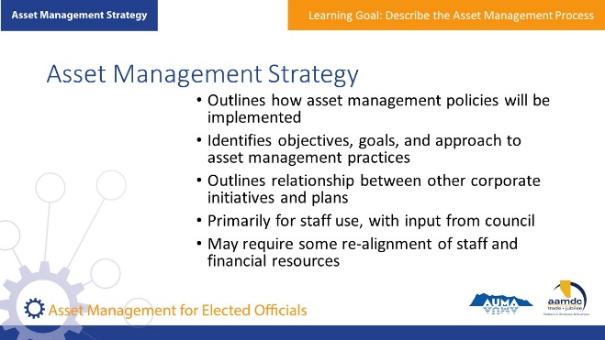 | State:  The asset management strategy should:  - Outline the framework and approach for implementing the asset management policy/policies  - Serve as the conceptual structure for the asset management system (series of practices and processes developed by the organization)  - Define the key components of the asset management system and interactions with other organizational processes (such as capital planning, budgeting, financial planning, etc.)  - Identify objectives (specific, measurable outcomes required of assets and asset management) and reporting requirements  - Provide an overview of current corporate assets, services, risks, costs, and funding  - State status of corporate asset management practices  - Identify goals (the general intent of your strategy, what you want to achieve at a high level) and timelines for the goals  - Outline the approach that you will take to improve asset management practices  - Outline relationships between other corporate initiatives or plans (such as the Municipal Development Plan, the Integrated Community Sustainability Plan, the Intermunicipal Collaboration Framework, etc.)
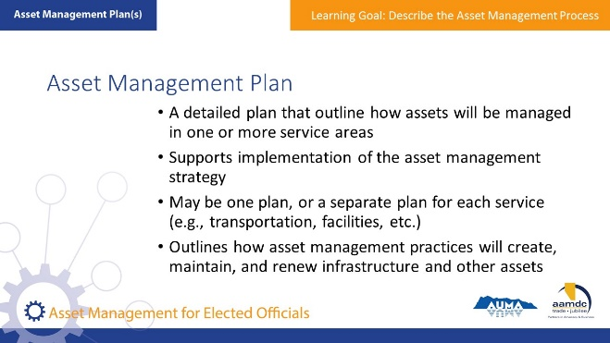 | State:  An asset management plan supports the implementation of the asset management strategy.  An organization may have one asset management plan, or it may have one for each grouping of assets.  It is unlikely that council will be involved in the development of the asset management plan – council’s direction should be provided through the policy and strategy. However, it is important for council to know whether or not the municipality has an asset management plan(s), and how these plans have been used to support processes like capital planning and budgeting.  Asset management plans may also be useful in providing information about cost, service, and risk to support council in evaluating trade-offs in decision-making.  Staff may provide updates on the progress of the asset management plan.
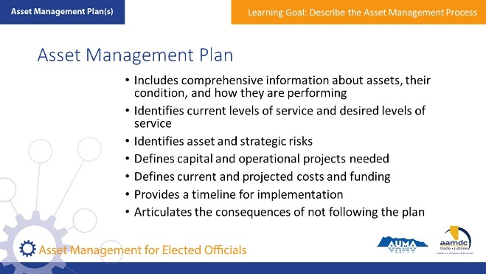 | State:  Asset management plans will:  - Outline specifically how asset management practices and processes will create, maintain, and renew infrastructure and other assets  - Provide comprehensive information about assets, their condition, and how they are performing  - Identify the current level of service performance and desired level of service  - Categorize asset risks and strategic risks  - Define capital and operational projects required to deliver service and mitigate risks  - Define current and projected costs and funding  - Provide a timeline for implementation  - Articulate the consequences of not following the plan
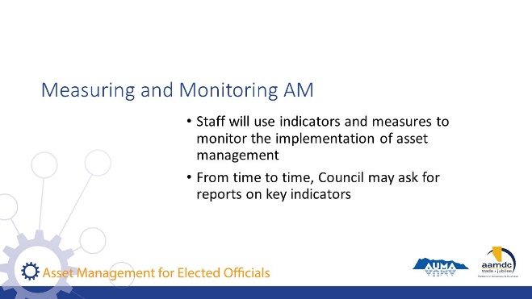 | State:  Staff will have indicators and measures they use to monitor the implementation of asset management.  Council will not need the details of all the indicators, but council may ask that the CAO report on a regular interval on some key indicators on outcomes that assure council that progress is being made to implement asset management.  One way of reporting on outcomes is to report on the sustainability of service delivery. Sustainable service delivery is at the core of asset management, so this is the ultimate outcome that council should be monitoring.  There is a tool developed to support staff in reporting on sustainable service delivery called the Service Sustainability Assessment Tool.  FCM also provides a self-assessment tool that evaluates progress on five competency areas. This is called the Asset Management Readiness Scale.
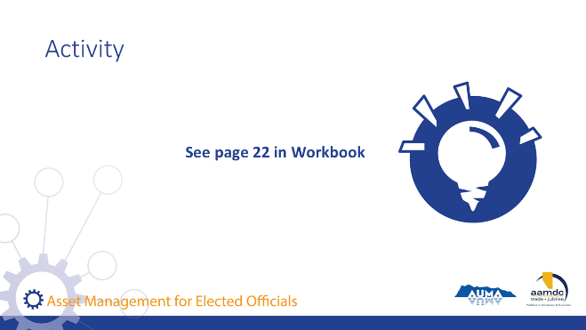 | Activity – Page 22 (15-20 minutes)  State:  On page 22 of your workbook, you’ll find a number of policy statements. Working with your table group, choose which policy statements you’d like to work with. You probably have time to work with about 3 or 4. For each statement, discuss and record your thoughts to each of the three questions:  - What’s the purpose of the statement?  - What are the strengths or weaknesses of the statement?  - Would the statement be suitable for your municipality? Why or why not? What would you change?  Debrief:  As a large group, discuss:  - What were some of the themes in the strengths or weaknesses of the policy statements?  - What would you be looking for in policy statements in your own municipalities?

Lunch Break
1 hour | 12:00 p.m. – 1:00 p.m.

NOTES

MODULE 2 – Fulfill the Role of the Elected Official in Asset Management

Learning Goal: Identify the Role of Elected Officials and Other Stakeholders

30 minutes | 1 p.m. – 1:30 p.m.
Slide | Script
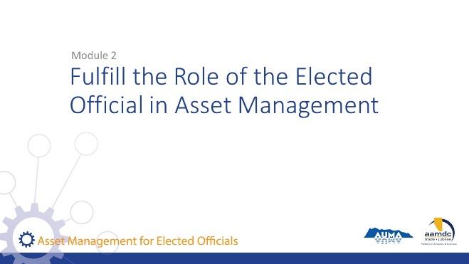 | State:  As an elected official, it’s critical you understand your role in asset management and the role of others. This next module is all about this. For the rest of the day, we will be focusing on:  - The role of the elected official and the role of other stakeholders in asset management  - Asset management considerations in standard municipal decisions, plans, and processes  - The role of an elected official in demonstrating commitment and internal leadership on asset management, as well as external leadership on asset management  - Using data and information in asset management  - The role of processes for planning and decision-making
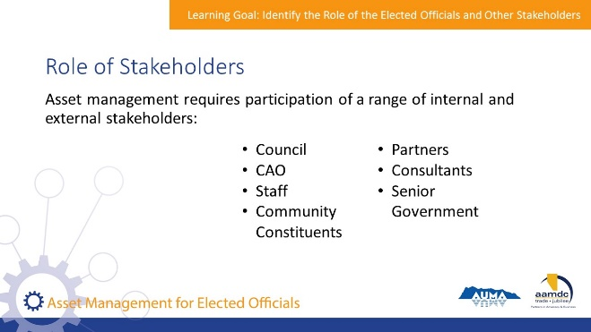 | State:  Effectively managing a municipality’s assets requires the involvement and commitment of a number of important players. We’re going to take a few minutes to discuss the role of each of them.  You can see these roles outlined in your workbook starting on page 23.  But first, who are the players?  - Council  - CAO  - Staff  - Community constituents  - Partners  - Consultants  - Federal and provincial governments  We’re going to look in some detail about the important role each plays in effective asset management.
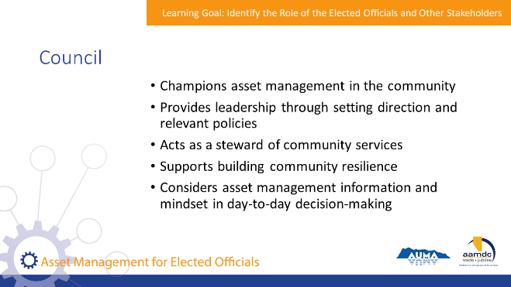 | State:  As a Council, your role is to:  - Champions asset management in the community  - Provide leadership through setting direction and relevant policies  - Acts as a steward of community services  - Support building community resilience  - Consider asset management information and mindset in day-to-day decision-making  - Allocate resources towards asset management through budgeting
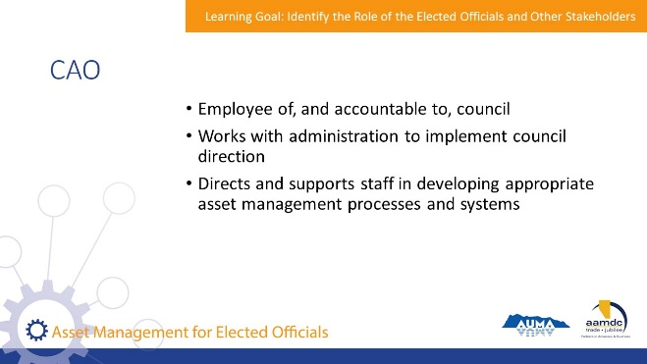 | State:  The CAO has a very different role from Council, but equally important:  - The CAO is the employee of, and is accountable to, council  - Responsible for working with administration to implement council direction  - Directs and supports staff in developing appropriate asset management processes and systems and shares information with council on asset management progress.
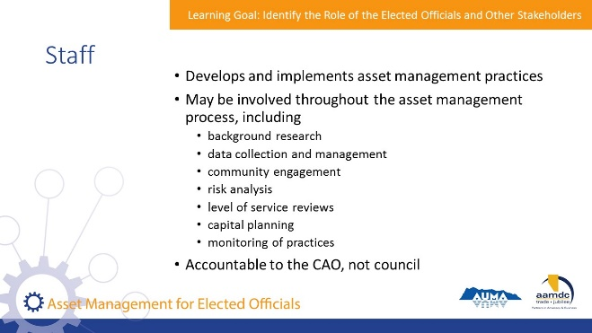 | State:  The role of Municipal Staff is to:  - Develop and implement asset management practices  - They may be involved throughout the asset management process, including background research, data collection and management, community engagement, risk analysis, level of service reviews, capital planning, and monitoring of practices  - Staff are accountable to the CAO, not council
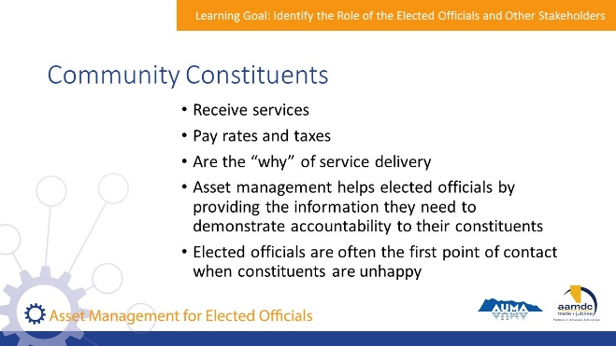 | State:  This may come as a surprise to some of you, but community constituents (tax payers) have a very important role to play in asset management. They are the ones who:  - Receive services  - Pay rates and taxes  - Form the “why” of service delivery  - Information and accountability are important to the relationship between the elected official and community members. Asset management helps to provide this information and demonstrate accountability.  - When community members are unhappy, the elected official may be their first point of contact.
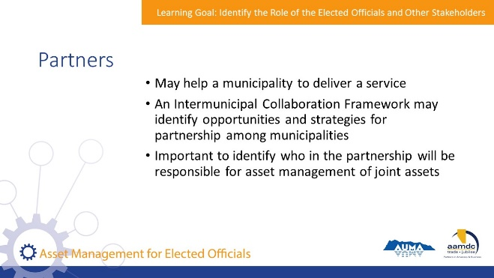 | State:  Partners may include other municipalities, other levels of government, or private service providers like EPCOR Utilities.  The role of partners may be to:  - Work with the municipality to deliver a service. In this case, the municipality will still need to steward sustainable service delivery.  - Deliver services to the public, or even to achieve asset management objectives, such as an up-to-date database of asset information.  - An Intermunicipal Collaboration Framework may identify opportunities and strategies for partnership among municipalities.  - In cases where partnerships relate to infrastructure-based services, it is important to identify who in the partnership will be responsible for asset management of joint assets.
State:
A consultant may be hired to provide specialized asset management services or for other aspects of service delivery where asset management may be relevant (e.g. establishing utility rates, etc.)

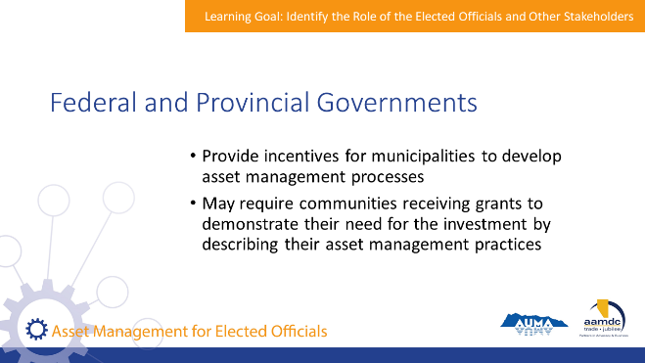 | State:  Other levels of government have implemented incentives for municipalities to develop asset management processes.  Federal and provincial governments may require communities receiving grants to demonstrate their need for the investment by describing their asset management practices.
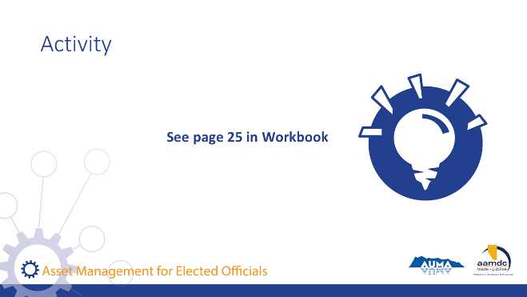 | Activity – Page 25 (12-15 minutes)  State:  On page 25 of your workbook, you’ll find an activity to discuss with your table group. Once you’ve had a chance to discuss the two questions, jot down your thoughts. We’ll ask a couple of you to volunteer to share your thoughts with the larger group.  Debrief:  Ask a couple of participants to share their thoughts with each of the questions.  If the group needs further ideas on question 2, some potential ways of collaborating on asset management are:  - Developing/maintaining a regional GIS system and asset inventory  - Collaborative capacity building (e.g. working together to attend training or hire a consultant in a way that builds the knowledge and skills of local staff).  - Becoming an informal local “community of practice”, sharing information and knowledge about how to improve in asset management. Sharing policies, strategies, etc.  - Developing joint public communication initiatives to raise awareness of the cost of service provision and the need to care for assets over time.  - Joint procurement of technical services where there are beneficial economies of scale.

Learning Goal: Use an Asset Management Mindset

45 minutes | 1:30 p.m. – 2:15 p.m.
Slide | Script
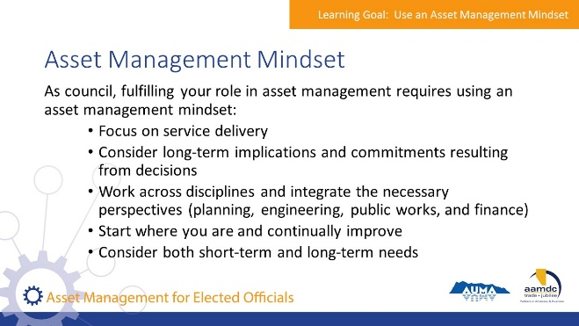 | State:  Implementation of asset management, especially from the perspective of council, is often about applying an asset management mindset to existing decision-making requirements.  So what do we mean by “asset management mindset”?  It is a way of considering services and service delivery in a sustainable way. An asset management mindset can be applied to a variety of municipal decisions, plans, and processes.  Having an asset management mindset means keeping a few things in mind at all times, like:  - Service delivery  - Long-term implications and commitments resulting from decisions  - Working across disciplines and integrating the necessary perspectives (planning, engineering, public works, and finance)  - Starting where you are and continually improving, meaning that Council can start with what information is available, and, over time, support staff in collecting better data on assets  - Considering both short-term and long-term needs  - Making decisions based on available information and evidence
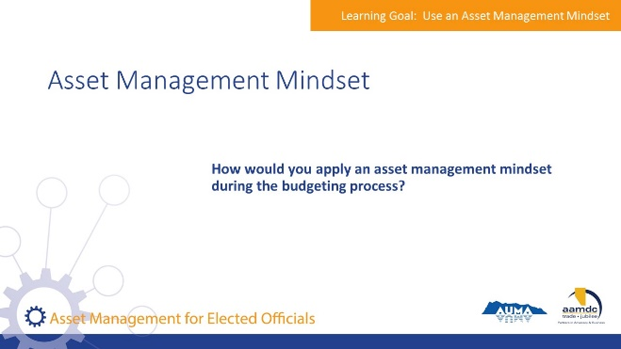 | Group Discussion  State: As a council, how would you apply an asset management mindset during the budgeting process?  Encourage participants to share their ideas.  State:  Those are all great ideas. Here are some questions we came up with.  Summarize the questions.
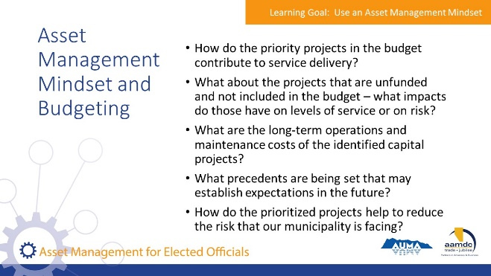 | State:  Council can apply an asset management mindset to budgeting by considering a few questions:  - How do the priority projects in the budget contribute to service delivery?  - What about the projects that are unfunded and not included in the budget – what impacts do those have on levels of service or on risk?  - What are the long-term operations and maintenance costs of the identified capital projects?  - What precedents are being set that may establish expectations in the future?  - How do the prioritized projects help to reduce the risk that our municipality is facing?  - Do we have the information that we need to support a decision?  Council can ask these questions of the CAO, who can provide information to support decision-making.  An asset management mindset can be applied to many other decisions and processes that council is involved in  The Asset Management Toolkit for Alberta Municipalities again is a great resource to help you think through these questions.
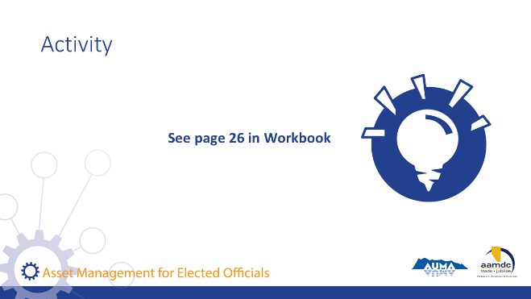 | Activity – Page 26 (15 minutes)  State:  On page 26 of your workbook, you’ll find an exercise to complete with your table group. We’ve already worked through the budget example as a group but think about some specific ways you could bring an asset management mindset to the budgeting process at your municipality.  Debrief:  Go through answers as a large group. See below for key ideas to ensure are mentioned.  Setting strategic priorities  - Understanding the strategic risks and major asset risks to the organization as an input to developing priorities  - Understanding the financial position of the municipality over the short, medium, and long term  - Understanding the current levels of service and how that compares to community expectations for levels of service  - Making sure that sustaining core services isn’t forgotten about, in favour of headline-grabbing issues  Preparing a municipal development plan  - Considering how development patterns impact infrastructure requirements and the long-term cost implications  - Considering how land use impacts the services provided by natural assets, and what the municipality may need to do to maintain or replace the services provided by these natural assets if the assets are disturbed  - Thinking about the levels of service that the municipality is committing to through various components of the MDP. Will these levels of service be sustainable? What are the costs associated with these levels of service (at a high level), and are they reasonable for the municipality?

Break
15 minutes | 2:15 p.m. – 2:30 p.m.

Learning Goal: Articulate the Role of an Elected Official in Providing Leadership on Asset Management

30 minutes | 2:30 p.m. – 3 p.m.
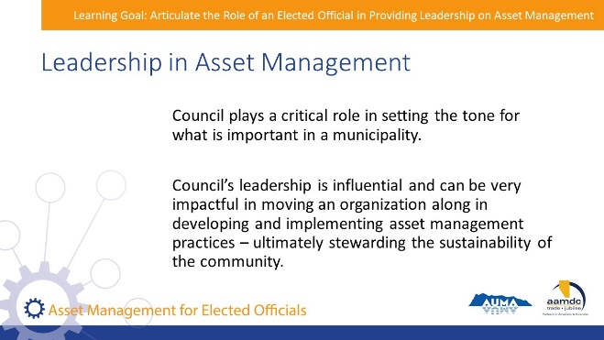 | State:  Council plays a critical role in setting the tone for what is important in a municipality. Council’s leadership is influential and can be very impactful in moving an organization along in developing and implementing asset management practices – ultimately stewarding the sustainability of the community.
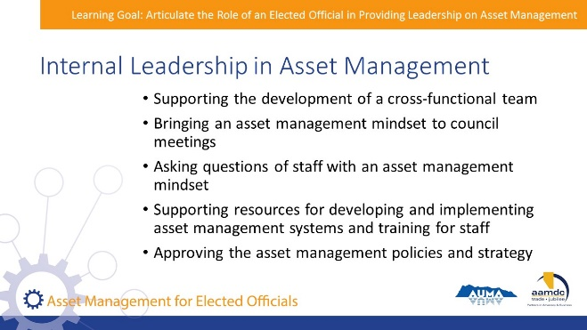 | State:  There are a few important and practical things council can do to demonstrate commitment to asset management internally:  - Support the development of a cross-functional team to lead asset management. This will reflect the size of your community: in smaller communities, it may mean the CAO and the public works manager working together; and in bigger communities, it may mean having a representative from each relevant department meeting regularly.  - Bring an asset management mindset to council meetings. Ask questions of staff to highlight the importance of considering asset management and sustainable service delivery in decisions.  - Advance asset management practices internally by supporting resources for developing and implementing asset management systems and training for staff.  - Approve the required policies and strategy to move the municipality forward with asset management
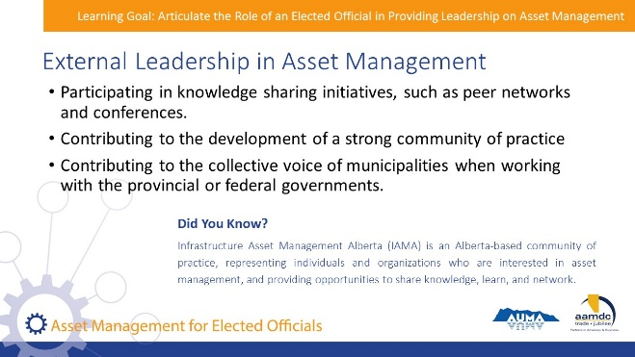 | State:  External leadership is also an important role for elected officials because it will ultimately improve the practices and sustainability of the municipality.  - Elected officials can show leadership through participation in knowledge sharing initiatives, such as peer networks and conferences, and through supporting staff in participating in these forums. Knowledge sharing forums, like conferences can be a great way to meet elected officials who are interested in asset management, as well as other champions of asset management such as staff at other municipalities and consultants.  - Coming together to share knowledge and best practices in asset management helps build a strong community of practice, and a collective voice for municipalities when working with the provincial or federal governments.
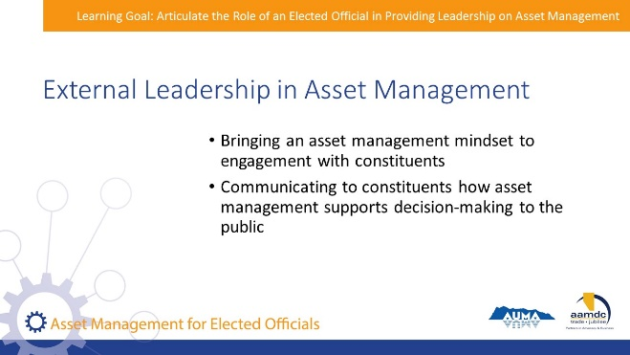 | State:  Elected officials can bring an asset management mindset to engagement with residents and help the public understand and appreciate how asset management supports decision-making.  This is especially helpful when constituents may be lobbying for specific projects when an asset management approach supports the defensibility of undertaking other priority projects.
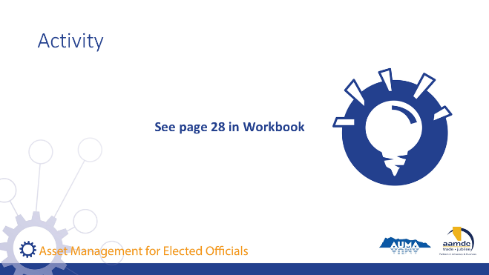 | Activity – Page 28 (20 minutes)  State:  Let’s put these concepts into actions. Turn to your workbook page 28 for another exercise. Read about the Town of Nimble. At your table group, answer the two questions provided there.  - What are some ways this council could provide internal leadership in asset management?  - What are some ways this council could provide external leadership in asset management?  Debrief  Ask a couple of tables to report back their thoughts on both questions. Some key points to emphasize are…  Internal leadership:  - Promoting a holistic asset management approach with staff. Asking for long term projections of risks and costs related to the water system, as well as other critical infrastructure.  - Asking staff to investigate and propose different risk management options for the water main (and other high-risk assets).  - Ensuring staff have required resources and training to be able to understand asset risks.  - Requesting full life-cycle costs of downtown beautification, that can be used when making decisions and communicating with constituents.  - Asking staff to evaluate various funding strategies for the projects, and including lifecycle costs.  External leadership:  - Consistently communicating costs of delivering services and the importance of core services.  - Being transparent with decision making.  - Engaging the public in a willingness-to-pay conversation regarding the downtown beautification projects.  - Evaluating longer-term strategies for increasing revenues to cover the costs of service delivery, and engaging the public in an ongoing dialogue about the need and the potential options.  - Participating in conversations with other similar municipalities to share approaches of addressing similar challenges.

Learning Goal: Effectively Use Data and Information

45 minutes | 3 p.m. – 3:45 p.m.
Slide | Script
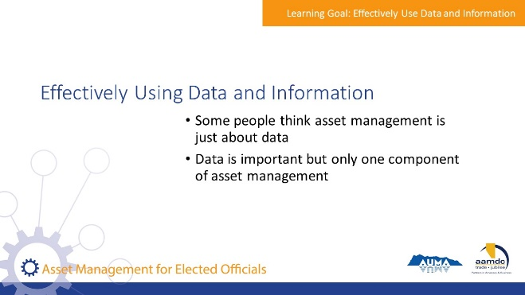 | State:  For some people, when they think about asset management, they immediately think about databases, inventory, and the never-ending quest for good data.  Data and information are important—good data ensures that your decisions are based on a solid understanding of your assets. However, it is important to remember that data is just one component of asset management, and data collection is an ongoing process that you can start and improve over time.  Read Quote in Workbook:  “There is a perception that asset management requires a lot of detailed data about all of your assets – but this information can be time consuming and costly to collect. Just like asset management, information management is a process of continuous improvement. It’s best to start by pulling together all of the data and information you already have to see what it tells you about your services, risks, and costs, and then to prioritize improving information where it’s going to make the biggest improvement to your decision-making.”  – Alberta Handbook and Toolkit, pg. 19  We’ll be reviewing various aspects of data and information involved in asset management. The purpose of this is not to give you a comprehensive review of how to collect, store, and use data – that will be up to staff in your organization.  We will focus on your role as elected officials and how it relates to data in asset management, as well as what kinds of information should be available and used in decision-making.
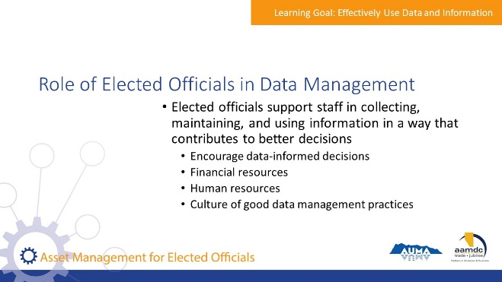 | State:  The key message we want to drive home today is that elected officials need to support staff in collecting, maintaining, and using information in a way that contributes to making better decisions.  Elected officials support staff by ensuring that appropriate levels of human and financial resources are available to collect and maintain data.  The level of resources required will depend on the size and complexity of the organization – but any organization can start with whatever information they have.
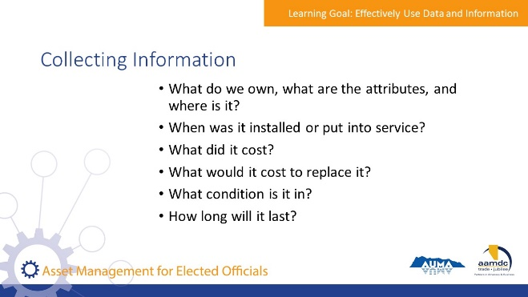 | State:  Asset management practices involve collecting and consolidating information about the municipality’s assets and services so that it’s available to inform decision-making. Information should be collected to answer the following questions:  - What do we own, what are the attributes, and where is it?  - When was it installed or put into service?  - What did it cost?  - What would it cost to replace it?  - What condition is it in?  - How long will it last?
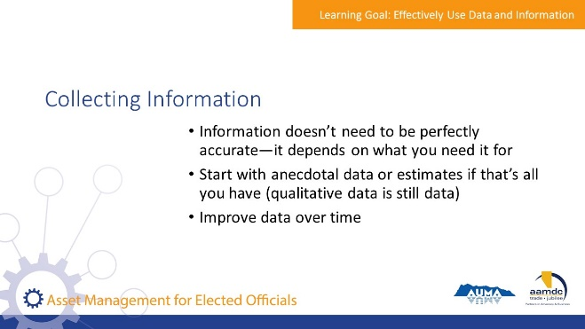 | State:  This information doesn’t need to be perfectly accurate – starting with even anecdotal information or estimates from knowledgeable staff provides value to decision-making.  The level of detail will depend on your needs and resources. For example, if you are trying to develop a long-term projection of what your asset replacement costs might be, assets can be grouped into large and general categories – there is no need to get into specific details because things will change over time and your aim is only to develop an estimate to help you plan. However, if you’re trying to decide which water mains should be replaced over the next two years, you will need more specific and accurate detail about size, location, fittings, connections, and condition.  You may have high levels of detail for some types of assets, and low levels of detail for other types of assets – it all depends on what is needed to reasonably inform decisions.  And remember, you can improve your data over time.
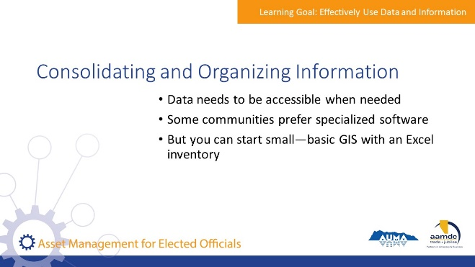 | State:  Once information is collected, it needs to be consolidated so that it can provide a snapshot of the state of the organization’s assets and is accessible for decision-making.  The information should be compiled and organized in a way that is appropriate to the municipality.  Specialized software may be preferred, but basic Geographic Information System (GIS) information with an excel inventory can be good enough for many small communities, and a great place to start for some larger communities.
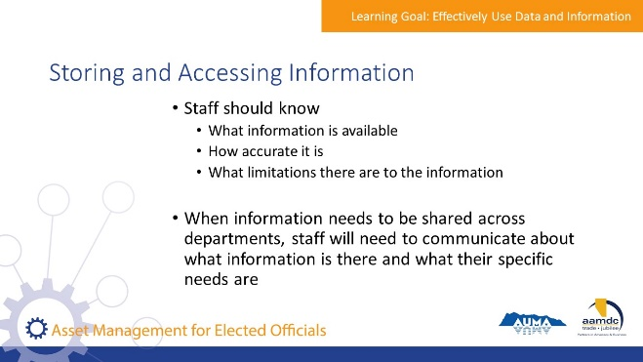 | State:  Staff should know what information is available, how accurate it is, and what limitations there are to the information.  When information is shared or accessed across departments, there should be effective communication about information needs.
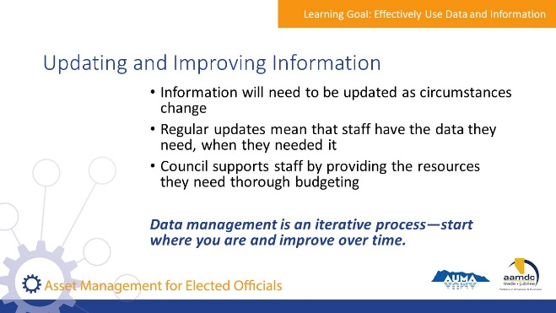 | State:  Information will need to be updated as circumstances change. Regular updates ensure that information remains usable.  Again, council’s role is not to update or improve information; council supports staff and provides the resources they need for updating and improving information, e.g., through budgeting for resources to support asset management practices.  Information doesn’t need to be completely accurate, it needs to be appropriately accurate. What is appropriate depends on the nature of the decisions it will be informing. High stakes decisions require higher accuracy information. For example, having the accurate location of water main valves is important because valves need to be accessed quickly in the event of a main break. But having the precise location of every park bench in the city is less important; it’s likely sufficient to know the number of benches in each park.  This is a process of continuous improvement – information doesn’t need to be perfect from day one.
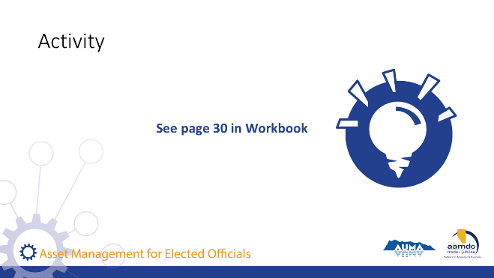 | Activity – Page 30 (15 minutes)  State:  Turn to page 30 in your workbook. Before you get started, you will need to have a look at the long-term capital plan on page 31. Then come back to this page and as a table group consider and write your answers to the two questions asked.  Debrief:  Ask a couple of tables to share their answers. Some key questions to emphasize:  - Why are these projects important?  - How do these projects help us to manage our risks to service delivery?  - What is driving the timing of these projects?  - What would be the risks associated with delaying these projects?  - What are the options for funding these projects?  - Are there any assets that are past their useful life that are not planned for renewal? If so, how are we managing the risk of failure?

Learning Goal: Understand and Follow the Asset Management Process

30 minutes | 3:45 p.m. – 4:15 p.m.
Slide | Script
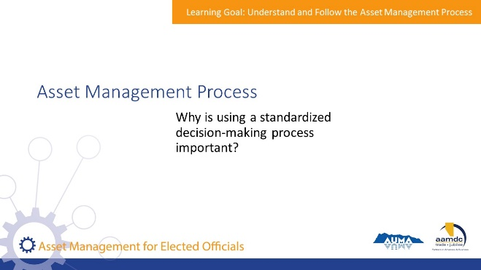 | Group Discussion  State:  Why is using a standardized decision-making process important?  Encourage participants to offer their ideas.  State:  Thanks for all your great answers.  Standardized decision-making processes for allocating resources can be a departure from how budgeting and decision making has been done historically in many communities. However, it provides elected officials, staff, and the community with a transparent process for making decisions, and provides clear rationale for capital planning and budgeting.  Using standardized decision-making processes means that your processes are written down and followed consistently, even by those who are new to the organization. These processes provide a consistent framework that is used to understand the need or problem, identify and evaluate the options for addressing the need or problem, and prioritize between competing needs to fit the available resources.
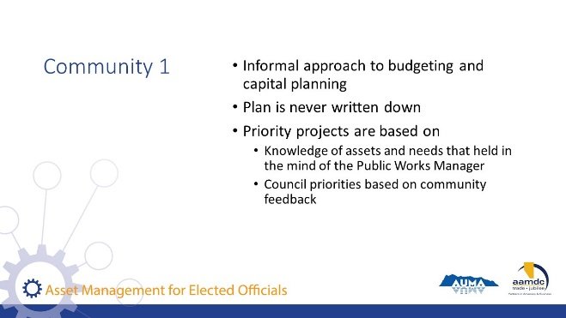 | State:  To illustrate why standardized decision-making processes are important, let’s consider two different communities.  The first community has an informal approach to budgeting and capital planning, but has never written it down. The Public Works Manager has been in the role for about 15 years, and since he has good knowledge of the community’s infrastructure, it’s up to him to identify projects for the capital plan and figure out how they should be prioritized. The plan is rounded out by adding the projects that council has identified to be important based on interaction with the community. Then the capital plan is approved.
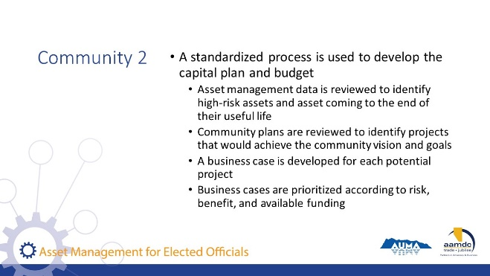 | State:  The second community uses written and standardized processes to develop the capital plan and budget. At the beginning of the process, a review of asset management data is conducted to identify high-risk assets and assets coming to the end of their useful life. Community plans are reviewed to identify projects that are important to achieving the community vision and goals. A business case is then developed for each potential project identified. Business cases are prioritized according to risk, benefit, and available funding sources.
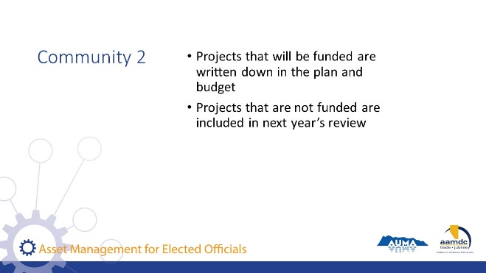 | State:  In the second community, projects that will be funded are included in the capital plan budget. Business cases for projects that are not funded are included for review in the process the following year.
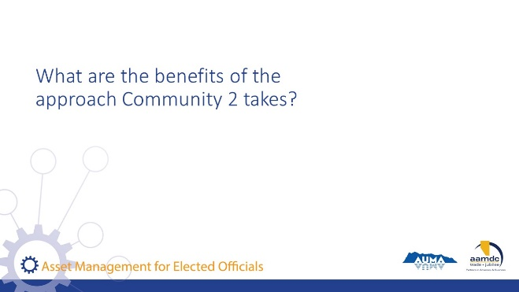 | State:  In the first community, we can’t definitively say whether the projects identified in the budget were the right projects or not. Since the Public Works Manager is the one identifying the majority of the projects, council and the community need to trust that he understands the risks and the priorities of the community. The plans are not defensible, and since there is no clearly defined method for developing the budget, the budget is more susceptible to being swayed by influential individuals or interest groups.  The second community can defend their budgets by pointing to the process and the evidence used to support decisions. Projects are more likely to proceed on merit and need, rather than on the ability of influential people to argue for them. It’s important to emphasize that staff experience and knowledge are still highly important in formal decision-making. However, it is documented and evaluated to demonstrate the evidence for taking one decision over another.
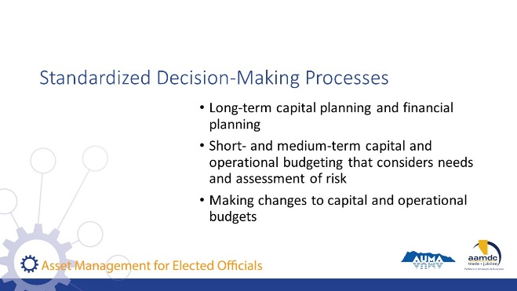 | State:  Using a standardized approach helps to place decisions within the context of overall strategic goals and resources. It mitigates the potential pitfalls of reactive decision-making that may prioritize issues with the loudest champions, rather than issues that have the greatest impact on the community. It also ensures that decisions in the short-term are made while considering long-term impacts.  Standardized decision-making processes should be used to support:  - Long-term capital planning and financial planning  - Short- and medium-term capital and operational budgeting that considers needs and assessment of risk  - Making changes to capital and operational budgets  Council does not develop decision-making processes but should understand how priorities are determined and ensure that staff have followed a process. When elected officials have a strong understanding of how decisions were made and how community input was taken into consideration, they are better equipped to liaise with community members, especially when there are questions about why some things were prioritized and not others.
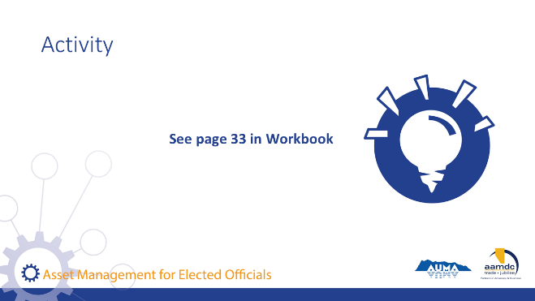 | Activity – Page 33 (15 minutes)  State:  Let’s turn to page 33 of your workbook and review the scenario. Working in your table groups, discuss and record your answer to the question below.  Debrief asking a couple of tables to offer their answers. Points to emphasize include…  - Looking at the long-term plan to understand if/when the roads are planned to be repaved in the future.  - Communicating the planning and decision-making process clearly and consistently with constituents to convey that there is transparent process for decision-making.  - Communicating commitments to level of service and how the municipality is managing risk with the constituents.  - Evaluating the impact of doing the requested repaving on other projects. What will then be delayed? What are the consequences of this delay?  - Ultimately, this is about using asset information to consider trade-offs between service, risk, and cost in making decisions.

Concluding Remarks and Evaluation Form

15 minutes | 4:15 p.m. – 4:30 p.m.
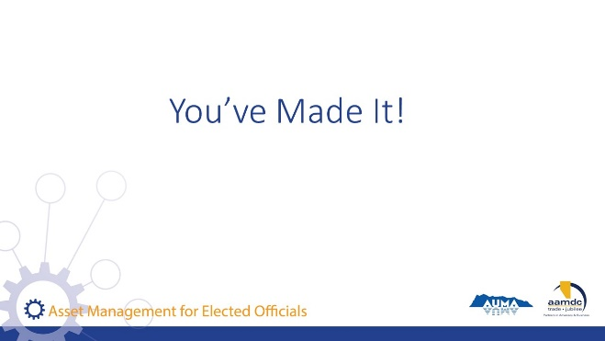 | State:  Well, you’ve made it!  Here you are at the end of the course. I hope you found today full of learning, good conversation, and shared insight. I want to thank you for joining us.  Remember, today is just a start. Together, we’ve laid the foundation, but we hope that you’ll continue to learn, ask questions, and participate in other opportunities to expand your knowledge of asset management. Throughout this book, and at the back, you can find the glossary and a list of resources if you ever need to reference something you learned in this course.
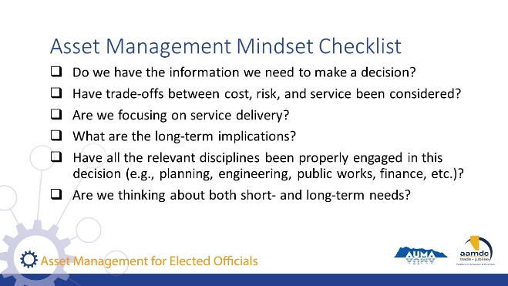 | State:  If you got anything out of today, we hope that it was an understanding of how an asset management mindset can support you in your role as an elected official and steward of community well-being. If you’re ever stuck, start by asking yourself some questions:  Read questions on slide.
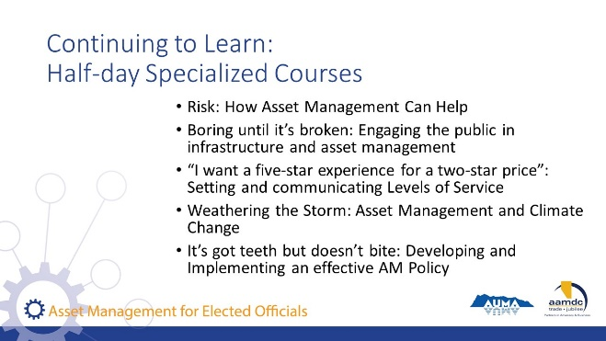 | State:  In addition to this full-day course on asset management, AUMA and AAMDC offer half-day courses designed for elected officials that go deeper into specific topics related to asset management:  Read course names on slide.
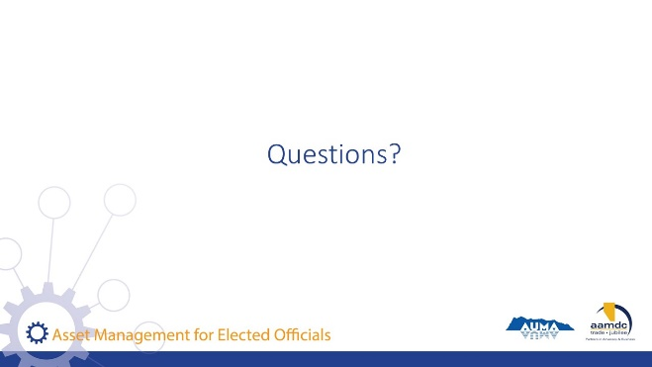 | State:  Before we leave for the day, does anyone have any remaining questions about anything we covered?
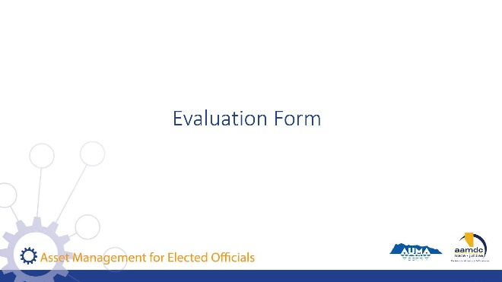 | State:  Before you leave today, we would really value getting your input on this course. Your input will help us to understand how the course helped you (what worked for you) and were we can be making improvements. Thanks for taking about 10 minutes to provide your feedback. Once completed, you can leave your forms on (pick a central location for all forms so they remain anonymous).

